Stakeholder Engagement Plan
Falp Wind Power Plant Project

Prepared for
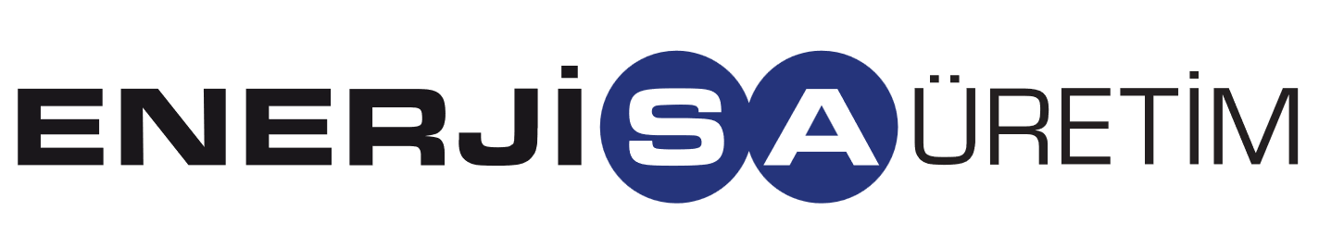
Enerjisa Enerji Üretim A.Ş.
Date
October 2025
Reference
0733614

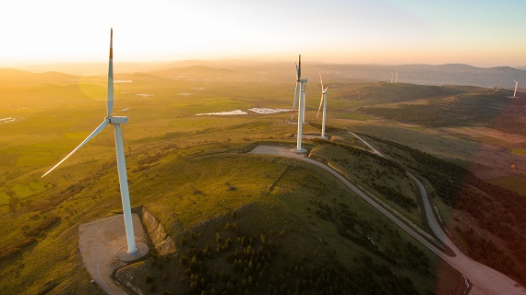
Document details
DOCUMENT TITLE | Stakeholder Engagement Plan
DOCUMENT SUBTITLE | Falp Wind Power Plant Project
PROJECT NUMBER | 0733614
DATE | October 2025
VERSION | 002
AUTHOR | ERM Project Team
CLIENT NAME | Enerjisa Enerji Üretim A.Ş.

Document history
 |  |  |  | ERM Approval to issue
Version | Revision | Author | Reviewed by | Name | Date | comments
Final Draft | 002 | ERM Project Team |  |  | October 2025

Signature page

Stakeholder Engagement Plan
Falp Wind Power Plant Project
0733614

Caner Sahin  Principal Consultant |  | Serkan Kirdogan  Partner
ERM GmbH Brüsseler Str. 1-3
60327 Frankfurt am Main

© Copyright 2025 by The ERM International Group Limited and/or its affiliates (‘ERM’). All Rights Reserved.
No part of this work may be reproduced or transmitted in any form or by any means, without prior written permission of ERM.

Contents
1. Introduction 4
1.1 SEP Principles and Objectives 4
1.2 Structure of the SEP 5
2. Project Overview 6
2.1 Brief Project Description 6
2.2 Project Parties 11
2.3 Area of Influence and Affected communities 11
2.4 Location and Land Requirements 15
3. Regulatory Context 16
3.1 Applicable National Standards 16
3.1.1 The Constitution of the Republic of Türkiye 16
3.1.2 Civil Code 17
3.1.3 Right to Information Law 17
3.1.4 Expropriation Law 17
3.1.5 Environmental Law 18
3.2 International Standards and Guidelines 18
3.2.1 IFC Performance Standards 18
3.2.3 Other Relevant Standards 21
3.3 Summary of Requirements 21
4. Stakeholder Identification, Mapping, and Analysis 21
4.1 Preliminary Stakeholder Identification 21
4.2 Stakeholder Mapping and Analysis 24
4.2.1 Approach and Purpose of Mapping 24
4.2.2 Preliminary High-Level Mapping 26
4.3 Considerations for Vulnerable Groups 26
5. Stakeholder Engagement Program and Approach 28
5.1 Past Engagement 28
5.3 Future Engagement 31
5.4 Participation Activities 32
5.5 Stakeholder Engagement Action Plan 33
5.7 Stakeholder Engagement for Change Management 46
6. Grievance Mechanism 47
6.1 Purpose and Principles of a Grievance Mechanism 47
6.1.1 Community Grievance Mechanism 49
6.1.2 Workforce Grievance Mechanism 49
6.1.3 Third Party Grievance Management 49
6.2 Grievance Mechanism Process 50
6.2.1 Step 1: RECEIVING AND RECORDING THE COMPLAINT 51
6.2.2 Step 2: RESOLUTION AND COMMUNICATION TO STAKEHOLDERS 52
6.2.3 Step 3: Grievance Close Out, Monitoring and Evaluation 52
6.4 Gender-Based Violence and HArassment Provisions 53
6.5 Support for Vulnerable Groups 54
6.6 Monitoring and Reporting 54
7. Roles and Responsibilites 55
8. Documentation, Monitoring, and Reporting 56
8.1 Documentation Tracking 56
8.2 Monitoring and Evaluation 57
8.2.1 Evaluation 59
8.2.2 Reporting to Stakeholders 59
Appendix A Stakeholder CONSULTATION FORM AND CONSULTATION REGISTER
Appendix B Sample Grievance Register
Appendix C Grievance Form

List of Tables
Table 2-1 Project Parties 11
Table 2-2 Neighborhood Coordinates and Distances to Project Boundary 11
Table 2-3 Distances from Nearest Settlements to Project Turbines 11
Table 2-4 Project-Affected SETTLEMENTS and surveys 14
Table 4-1 Stakeholder Category List 22
Table 4-2 Vulnerable groups in the Project AoI 27
Table 5-1 Stakeholder Engagement Action Plan 34
Table 7-1 Roles and Responsibilities for SEP Management 55
Table 8-1 SEP Key Performance Indicators 57

List of Figures
Figure 2-1 YEKA-2 PROJECTS OF Enerjisa Enerji Üretim A.Ş. 7
Figure 2-2 PROJECT LAYOUT – 1 9
Figure 2-3 PROJECT LAYOUT – 2 10
Figure 2-4 Nearest Settlements 13
Figure 4-1 Stakeholder Priority Matrix 25
Figure 4-2 Preliminary Stakeholder Mapping 26
Figure 5-1 Project Advertisement in National Newspaper 29
Figure 5-2 Project Advertisement in Local Newspaper 30
Figure 6-1 Grievance Mechanism Process 50

Acronyms and ABBREVIATIONS
Acronyms | Description
AoI | Area of Influence
CGM | Community Grievance Mechanism
CLO | Community Liaison Officer
CSO | Civil Society Organization
EHS | Environmental, Health, and Safety
EIA | Environmental Impact Assessment
ESG | Environmental, Social and Governance
ESIA | Environmental and Social Impact Assessment
ESR | Environmental and Social Requirement
GBVH | Gender-Based Violence and Harassment
GM | Grievance Mechanism
HSE | Health, Safety and Environmental
IFC | International Finance Corporation
ILO | International Labor Organization
KPI | Key Performance Indicator
LRF | Livelihood Restoration Framework
NGO | Non-Governmental Organization
NTS | Non-Technical Summary
PAPs | Project-Affected-Person
PS | Performance Standard
RFI | Request for Information
SEP | Stakeholder Engagement Plan
SIA | Social Impact Assessment
SLO | Social License to Operate
UN | United Nations
UNGPs | United Nations Guiding Principles on Business and Human Rights
WB | World Bank

Introduction
This document is the Stakeholder Engagement Plan (SEP) for Enerjisa Enerji Üretim A.Ş.’s (or ‘the Client’) Falp Wind Power Plant Project (‘the Project’) that is planned to be built within the boundaries of Muğla Province, Milas District, and Aydın Province, Karpuzlu District of Türkiye. This SEP is intended to guide information sharing and engagement with the Project’s stakeholders in a clear, transparent, and effective manner. Engagement with stakeholders is crucial to establishing their understanding of the Project, its activities, potential risks and impacts, and to also build trust and support for the Project. The SEP will also aid the Client’s overall compliance with Turkish legislation and the intended lender’s applicable standards.
This SEP is intended for internal usage amongst the Project development team and for Project lenders to understand the Client’s protocol for engagement with potentially affected persons (PAPs) and other stakeholders. It also includes a comprehensive Grievance Mechanism (GM) with protocols for a Community Grievance Mechanism (CGM), Workforce Grievance Mechanism and Contractor/Subcontractor Grievance Mechanism. This management plan will also be made available to all stakeholders and shall be actively reviewed by the Project team to showcase any Project changes or developments and integrate feedback from stakeholders where possible.
For this Category B project, information disclosure and stakeholder engagement will be conducted in line with the requirements of ESR 10 and national regulations. The SEP, Non-Technical Summary (NTS), key management plans such as the Biodiversity Management Plan (BMP) will be disclosed to the public.

SEP Principles and Objectives
This SEP has been established around the key principles of stakeholder engagement as defined by the International Finance Corporation (IFC) Performance Standards (PSs)– namely Performance Standard (PS) 1. The key principles are as follows:
- Open and transparent engagement: the Client shall establish open, honest, fact-based, and transparent engagement with Project stakeholders throughout the entire Project life cycle.
- Listening and dialogue: engagement efforts must show that stakeholder concerns are heard and addressed in a clear, fair, and appropriate manner.
- Inclusive and active participation: engagement activities shall be inclusive in representation of views and accessible to all stakeholders (including vulnerable persons/groups) to promote active and meaningful engagement.
- Proactive and timely engagement: the client shall proactively initiate engagement so as to ensure that information is shared and concerns are addressed in a timely manner; failure to do so may allow issues to unintentionally scale, therefore having potentially adverse consequences in terms of managing social risks and impacts of the Project.
- Safe participation: all stakeholders shall feel safe enough to be able to engage with Project proponents and share their concerns without fear of persecution or risk of retaliation. This includes ensuring that a private space can be provided where possible or necessary.
- Appropriate form of engagement: all communication shall be culturally appropriate, understandable to local stakeholders and effective overall.
- Empowering and responsive: the Client’s team shall collaborate with stakeholders as equals to seek incorporating feedback into project or program design, while reporting back to stakeholders. Engagement will be based on active dialogue to establish the best solutions that include compromise or meet common interests. It is crucial that engagement is not discursive to stakeholders and PAPs.
- Respectful: all stakeholders and their opinions and interests shall be treated with respect throughout all engagement efforts.
This SEP intends to clear, consistent, comprehensive, appropriate, inclusive, and accessible guidance in line with the aforementioned principles, lender requirements and Turkish national legislation. The primary objectives of this SEP are to:
- Identify, map, and analyze stakeholders that are: (i) affected or likely to be affected (either directly or indirectly) by the Project during all stages of its lifecycle (planning through decommissioning); or (ii) those that may have an interest or influence in the Project so as to ensure that they are included in the communication process.
- Determine potential stakeholder related risks to the Project and consider appropriate measures to manage or mitigate them.
- Create protocols to keep stakeholders appropriately and meaningfully engaged throughout the Project lifetime.
- Describe the process that stakeholders shall share their comments, feedback, ask questions and raise grievances and the corresponding or relative protocols in which the Client shall perspectives and information.
- Establish provisions for stakeholder feedback integration into Project development as much as possible.
The Grievance Mechanism in Section 0 will help guide the process of managing and responding to stakeholder (internal and external) concerns. The Client will manage and maintain this GM according to the stipulated process throughout the entire Project life cycle.
The SEP also specifies organizational capacities necessary to ensure the proper implementation of this SEP and management of all engagement activities. This includes an overview of the scope of roles and responsibilities, specification on documentation, monitoring, reporting, and evaluation related to the engagement activities.

Structure of the SEP
The remainder of this SEP is structured as follows:
- Section 2, Project Overview
- Section 3, Regulatory Context
- Section 4, Preliminary Stakeholder Identification, Mapping and Analysis
- Section 5, Stakeholder Engagement Program and Approach
- Section 6, Grievance Mechanism
- Section 7, Roles and Responsibilities
- Section 8, Documentation, Monitoring, and Reporting
This SEP also includes the following annexes:
- Appendix A: Stakeholder Consultation Form and Consultation Register
- Appendix B: Sample Grievance Register
- Appendix C: Grievance Forms

Project Overview

Brief Project Description
As a result of the YEKA-RES-2 tender conducted by the Ministry of Energy and Natural Resources, Enerjisa Enerji Üretim A.Ş. won the right to connect 250 MWe in the Muğla Connection Region. Under Muğla Connection Region of the YEKA RES-2, Enerjisa Enerji Üretim A.Ş. plans to establish three wind power plants; Falp WPP (18 Turbines – 75.6 MWm / 75.6 MWe), Arturna WPP (22 Turbines – 92.4 MWm / 92.4 MWe) and Gaia WPP (20 Turbines - 84 MWm / 84 MWe) within the borders of Muğla and Aydın Provinces of Türkiye, as shown on the map below.
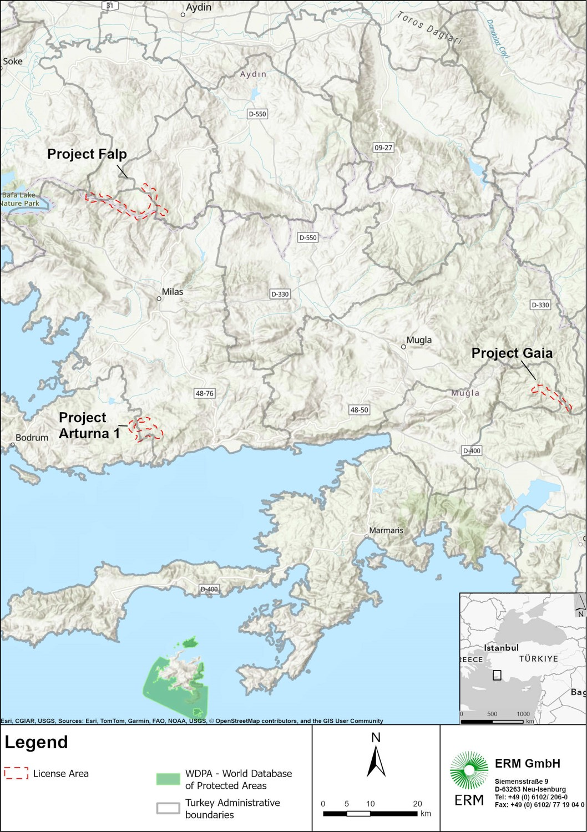
Figure 2-1 YEKA-2 PROJECTS OF Enerjisa Enerji Üretim A.Ş.

Falp WPP Project is planned to be constructed and operated by Enerjisa Enerji Üretim A.Ş. within the boundaries of Muğla Province, Milas District, and Aydın Province, Karpuzlu District.
The Project consists of 18 wind turbines (each with a capacity of 4.2 MWm/4.2 Mwe), 1 switchyard, access roads, 3 excess excavation material storage areas (if needed), mobilization areas and no activities other than these units will be carried out within the scope of the planned project at this stage.
The total installed capacity of the facility will be 75.6 MWm / 75.6 MWe. The projected annual electricity generation of the project is estimated to be 231,948,360 kWh/year.
A 22 km length with 154 kV ETL will be installed for the Project. During the development of this SEP, the exact route of the ETL has not been approved yet. The details of the alignment are defined in the ESIA.
The distance from the FALP WPP site to the nearest highway expropriation boundary is 4.75 km. Access to the project site can be provided by the connection roads from the D252 Milas-Söke highway through the Derince-Sakarya village road direction. During the construction phase, existing roads will be used as much as possible for transportation to the project site and these existing roads will be improved if necessary. Any newly constructed permanent access roads to the project site will be open for public use once construction is completed.
The layout of the Project is given in Figure 2-2 and Figure 2-3 below.
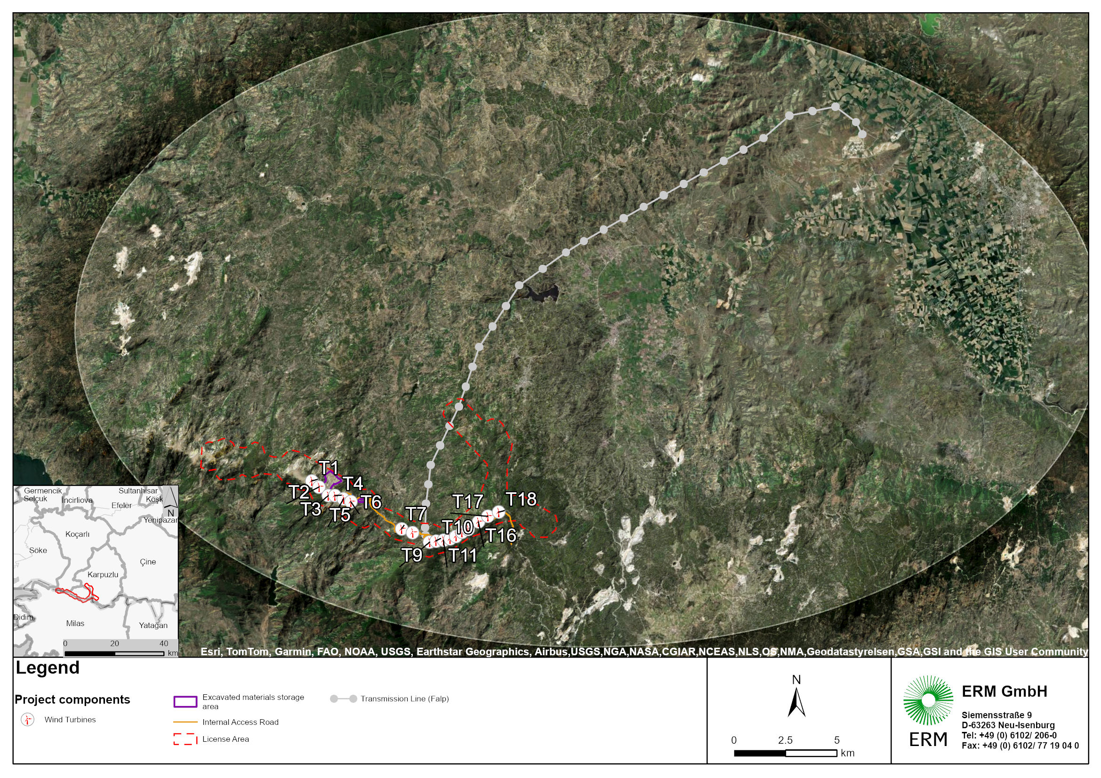
Figure 2-2 PROJECT LAYOUT – 1

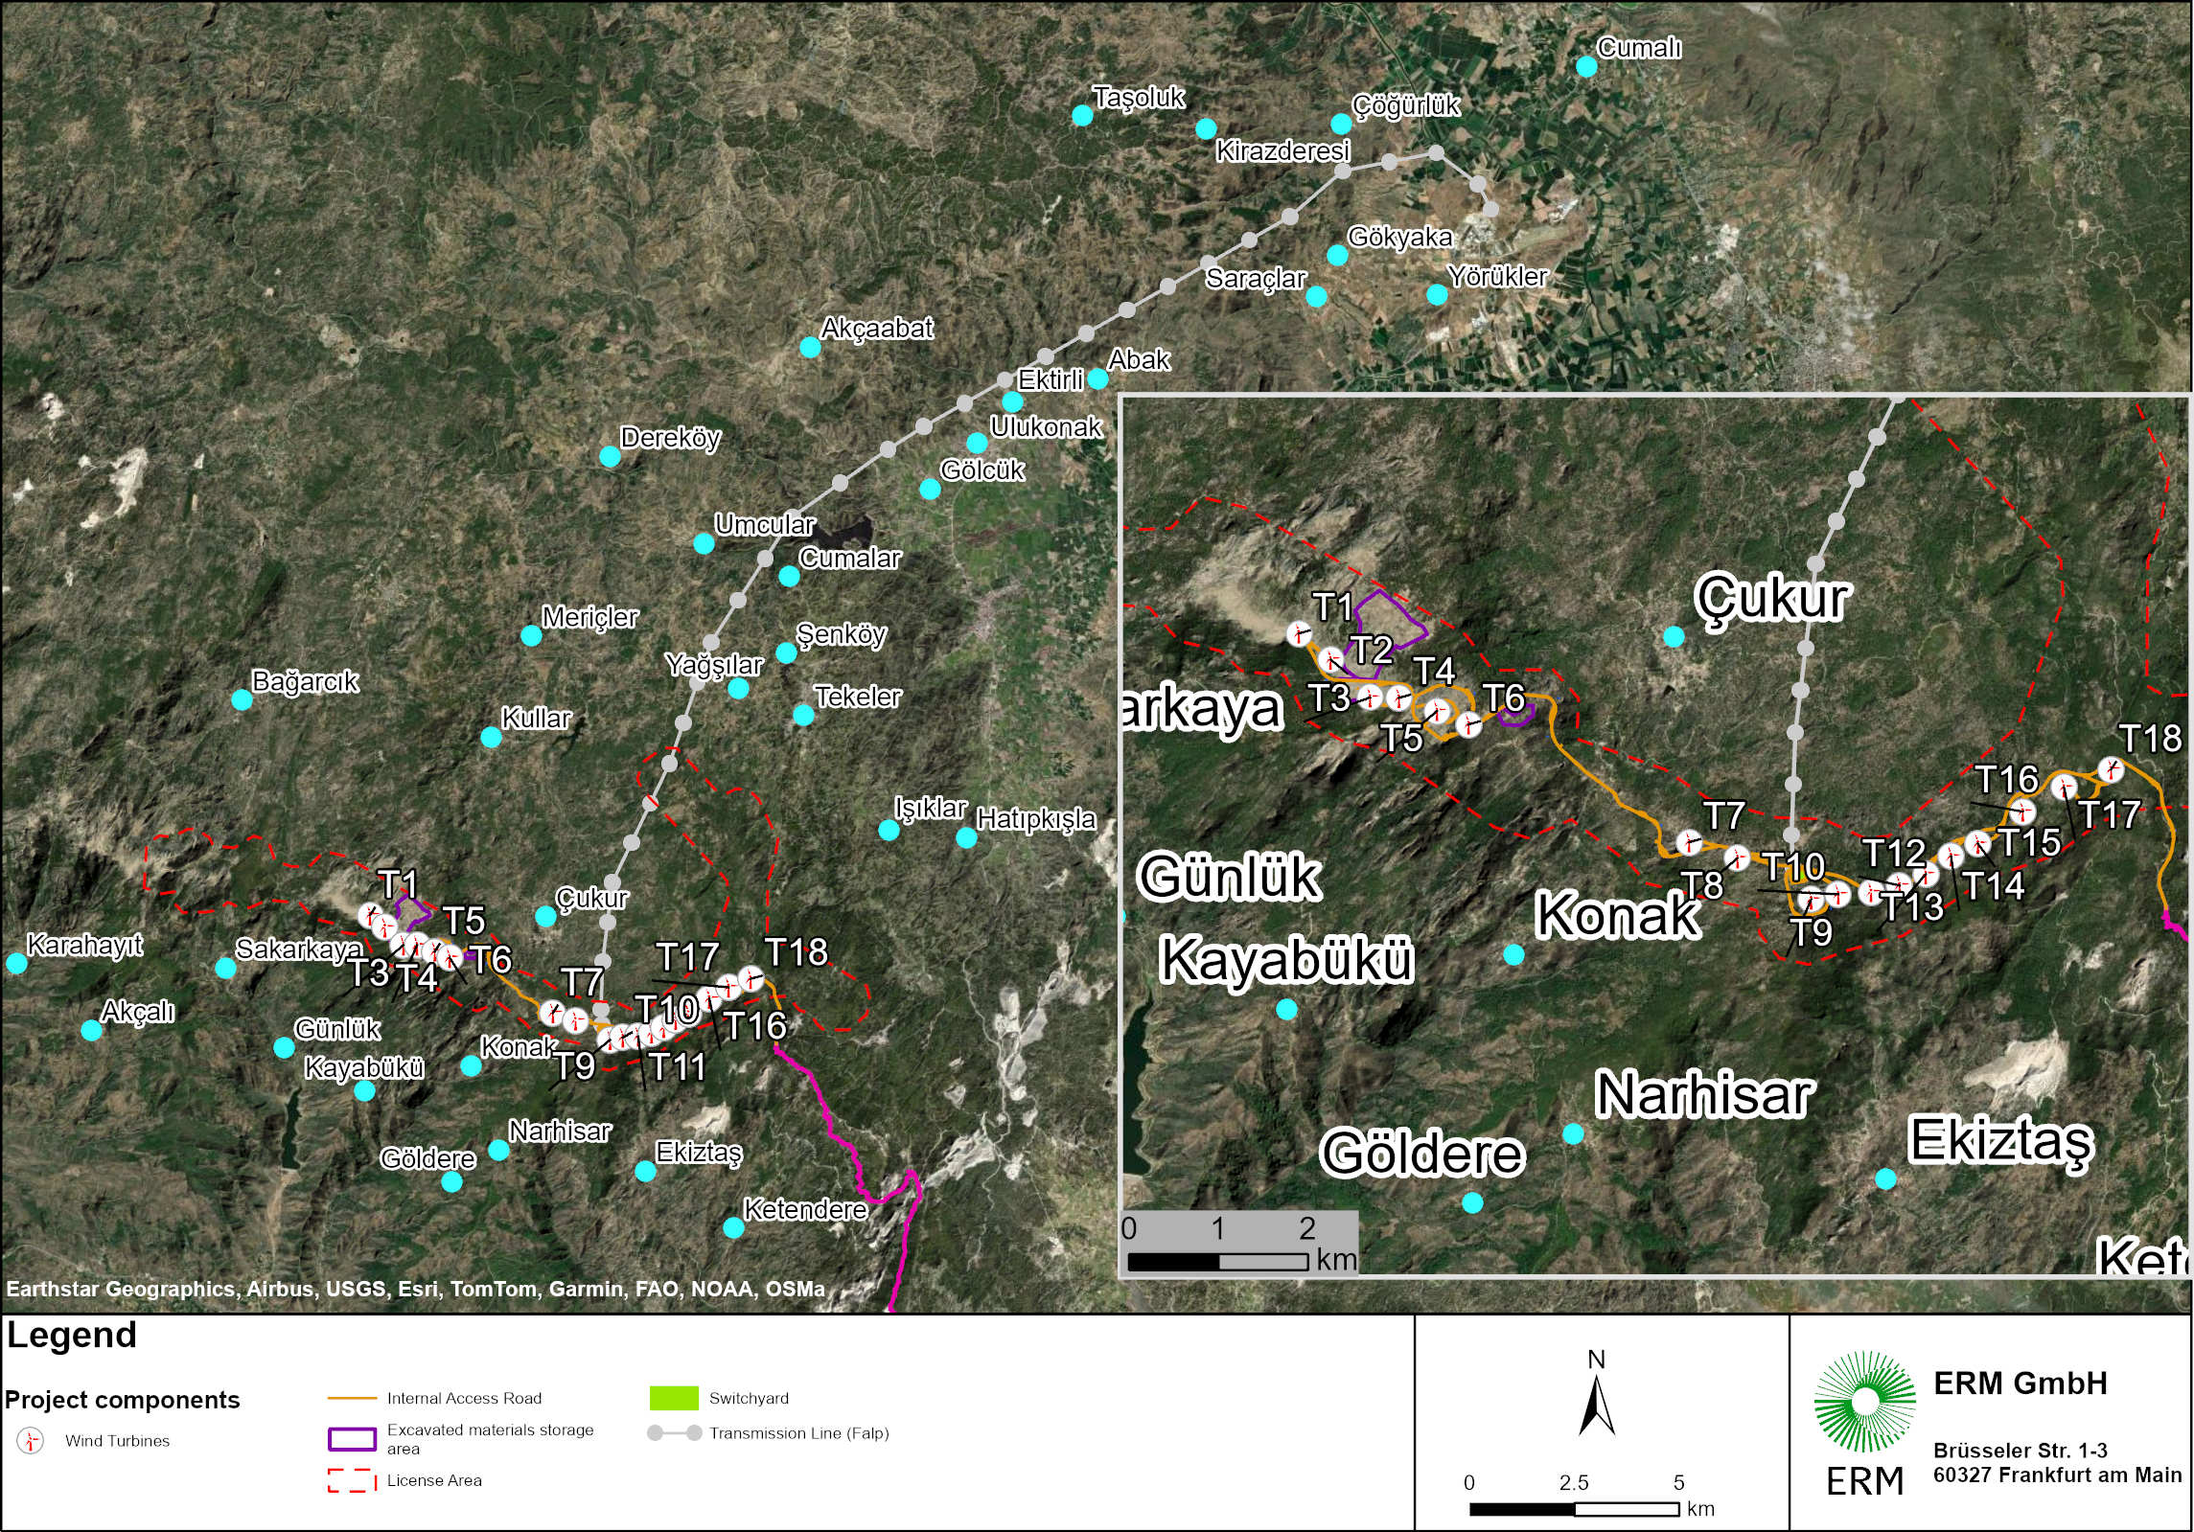
Figure 2-3 PROJECT LAYOUT – 2

Project Parties
The parties involved in the Project are listed in Table 2-1 below.
Table 2-1 Project Parties
Responsible Party | Role | Responsibilities
Enerjisa Enerji Üretim A.Ş. | Project Owner | - Development of Project design  - Procurement of Project components  - Construction of the Project  - Operation of the Project
ERM | International sustainability consultancy firm engaged by the Project Owners | - Development of Scoping Report  - Development of ESIA Report  - Development of Management Plans & SEP

Area of Influence and Affected communities
The nearest settlements within a 2 km buffer of Project boundary are:
- Çukur Neighborhood – approximately 1.2 km southeast of the Project boundary;
- Konak Neighborhood – approximately 1.3 km southwest;

The neighborhoods located near to Project Area or its components are given in the tables below.
Table 2-2 Neighborhood Coordinates and Distances to Project Boundary
Neighborhood | District | Distance to Project Boundary | Latitude | Longitude
Çukur | Milas | 1.20 km | 37°29'35.47"N | 27°42'56.31"E
Konak | Milas | 1.30 km | 37°27'52.91"N | 27°41'39.73"E
Narhisar | Milas | 2.80 km | 37°26'46.69"N | 27°42'13.32"E

Table 2-3 Distances from Nearest Settlements to Project Turbines
Neighborhood | Direction | Distance to Nearest Turbine (m) | Nearest Turbine
Sakarya | West | 3,062 | T1
Konak | Southwest | 2,165 | T7
İkiztaş | South | 2,958 | T11
Ketendere | South | 2,893 | T13
Ketendere | South / Southeast | 2,851 | T18
Hatıpkışla | East | 3,560 | T18
Tekeler | North / Northeast | 1,955 | T18
Tekeler | North / Northeast | 2,837 | T18
Tekeler | North / Northeast | 3,650 | T18
Tekeler | North / Northeast | 4,935 | T18
Koğuk | Northeast | 4,935 | T18
Yağşılar | North | 6,504 | T18
Yağşılar | North | 6,052 | T18
Çukur | North | 5,330 | T16
Çukur | North | 1,938 | T7

The nearest settlements of the Project are shown in Figure 2-4 below.

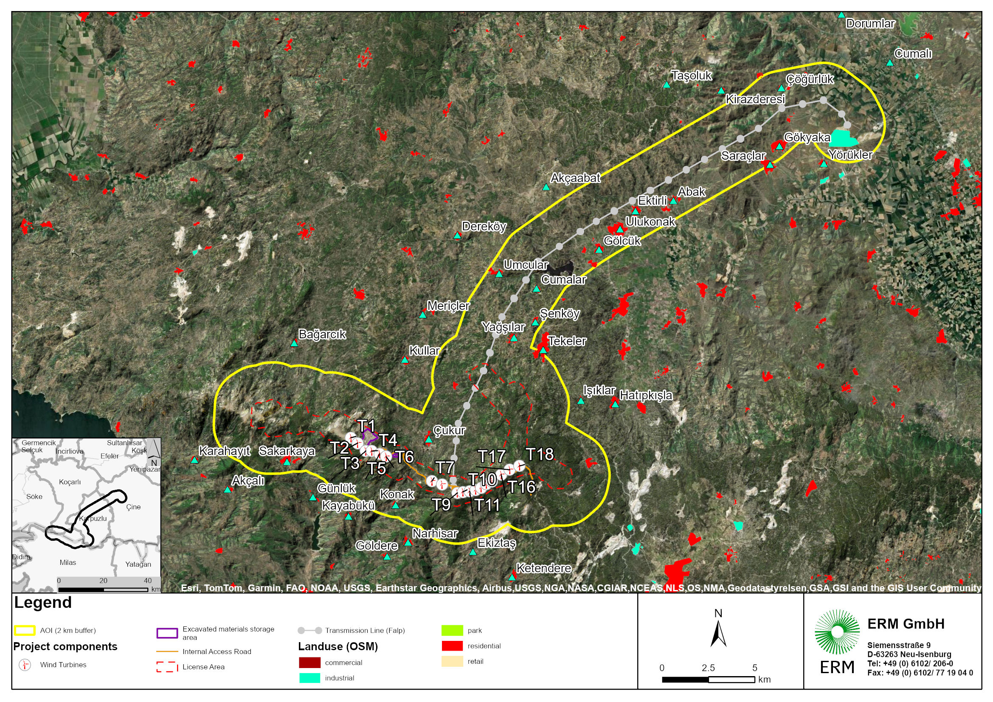
Figure 2-4 Nearest Settlements
The fieldwork for the Project was conducted by a research team of six people over six days, from 11-17 July 2024, in the project-affected settlements (PAS). Within the scope of fieldwork, surveys and interviews were conducted in the PAS presented in Table 2-3. While some settlements interviewed expressed positive opinions about the Project, others expressed concerns regarding the Project. Details on opinions and surveys is presented in the ESIA report.
Table 2-4 Project-Affected SETTLEMENTS and surveys
Province/District | Settlement/Cadastral Zone | Number of Surveys Conducted
Muğla/Milas | Sakarkaya | 25
Muğla/Milas | Kayabükü | 6
Muğla/Milas | Çukur | 14
Muğla/Milas | Konak | 9
Muğla/Milas | Narhisar | 10
Muğla/Milas | İkiztaş | 15

A second field study was carried out between 20–23 March 2025, targeting settlements newly impacted by revised access road alignments and the ETL corridor. Village-level assessments were carried out in:
• Gökyaka
• Saraçlar
• Ektirli
• Ulukonak
• Gölcük
• Umcular
• Cumalar
• Abak
• Şenköy
• Kırcağız
• Kargıcak
• Sarıkaya
• Çukurköy (revisited)

Location and Land Requirements
The project area is classified as "Forest Area" according to the Aydın-Muğla-Denizli Planning Region 1/100,000 Scale Environmental Layout Plan.
Within the scope of the Project, 17 of the planned 18 turbines will be located within the borders of Muğla Province, while one turbine (T2) will be situated within the borders of Aydın Province. Furthermore, the entire excess excavation material storage area No. 1 and a portion of excess excavation material storage area No. 2 will (if needed) also be within Aydın Province. Consequently, approximately 90% of the project area falls within Muğla Province, and about 10% is within Aydın Province borders.
The local EIA states that the project site and turbine locations were determined in line with the opinions of the General Directorate of Mining and Petroleum Affairs, General Directorate of Forestry, General Directorate of Nature Conservation and National Parks, Metropolitan Municipalities in Türkiye and all other institutions that are members of the commission within the scope of the project. The selected area has been planned to ensure minimal habitat loss and minimal tree cutting.
While the wind turbine sites of the FALP Project are primarily located on registered state forest land, additional land is required for the development of associated facilities such as access roads, the energy transmission line (ETL), and temporary construction infrastructure. These additional components intersect treasury-owned land, privately owned parcels, and unregistered plots. Therefore, a combination of long-term permits, easement rights, and expropriation procedures are being applied in accordance with the applicable legislation. A review of the land ownership status for access road alignments shows that a total of 6 parcels will be affected, including 1 treasury-owned parcel, 3 forestry parcels and 2 privately owned parcels.
In Türkiye, the construction and operation of ETLs fall under the authority of the Turkish Electricity Transmission Corporation (TEİAŞ). TEİAŞ is the ultimate responsible body for project approval, land acquisition and easement establishment, construction management, and long-term operation of ETLs. The Project Company has prepared the design and undertaken preparatory works on behalf of TEİAŞ; however, ownership, accountability, and regulatory authority throughout the process remain with TEİAŞ. Since the ETLs belong to TEİAŞ, the entire expropriation process is being carried out by TEİAŞ. However, in cases where Enerjisa Üretim need to expedite the process to start pole installations at site earlier, Enerjisa Üretim may hold negotiations with the landowners of the parcels where the poles will be located, prior to the expropriation. In such cases, consent forms may be signed in exchange for payments made to the landowners based on a pre-determined amount per pole. The ETL route has been finalized as of October 2025. The expropriation process for the parcel in has not been started by TEİAŞ.
According to the latest design, it passes through several settlements, including Gökyaka, Saraçlar, Ektirli, Ulukonak, Gölcük, Umcular, Cumalar, Abak, Şenköy, and Çukur. A total of 410 private parcels and 89 forest/treasury parcels are affected by the ETL route. Of these 410 private parcels, 67 parcels are directly impacted by pole installations, while the remaining 343 are affected by the overhead electrical cables. The land types along the ETL corridor include state forest land, treasury land, and private parcels. For treasury lands, easement rights will be applied to allow legal use of land for transmission infrastructure, without transferring ownership. In the case of privately owned parcels, easement expropriation will be conducted under Law No. 2942. These rights allow the Project to use the land for aboveground or underground infrastructure while the ownership remains unchanged. Under EBRD Environmental and Social Requirement 5 (ESR5), compensation for parcels expropriated by a national government must follow principles that ensure fairness and livelihood restoration. The process should aim to avoid or minimize displacement, and when unavoidable, affected persons must receive compensation at full replacement cost, including transaction fees, without deductions for depreciation. Compensation must be provided before displacement occurs, and the project sponsor is responsible for ensuring that government-led expropriation aligns with ESR5 standards. This includes verifying that compensation is adequate, timely, and that vulnerable groups are protected. Additionally, negotiated settlements are preferred, provided they are transparent and based on informed consent.
Under EBRD Environmental and Social Requirement 5 (ESR5), informal land users are still entitled to compensation and support if they are displaced (physically or economically) due to expropriation. ESR5 emphasizes that all affected persons, regardless of legal status, must be treated fairly and compensated at full replacement cost for lost assets and livelihoods. This includes support for restoring or improving living standards and income sources. Enerjisa Üretim must ensure that informal users are identified early, consulted meaningfully, and provided with appropriate resettlement assistance and livelihood restoration measures, even if the expropriation is carried out by a national government.

Regulatory Context
This SEP will be maintained, adjusted, and implemented in line with the following national and international standards and requirements. Where there is discrepancy between requirements, the Client shall follow the more stringent recommendations and requirements.

Applicable National Standards
The most relevant national standards for this Project’s stakeholder engagement are:
- The Constitution of the Republic of Türkiye
- Turkish Civil Code
- The Law on the Right to Information
- The Law on the Right to Petition
- Turkish Expropriation Law
- And Turkish Environmental Law.

The Constitution of the Republic of Türkiye
The Constitution of the Republic of Türkiye is the main national legislation that will guide the implementation and maintenance of this SEP.

Article 25 Freedom of thought and Opinion
Article 25 of the constitution maintains that everyone is entitled to have their own thoughts and opinions without being compelled to reveal such information for any specific reason or purpose. Furthermore, no person shall be blamed or condemned for any thoughts or opinions.

Article 26 Freedom of expression and Dissemination of Thought
Article 26 of the constitution stipulates that all people are entitled to the right to express and share their thoughts or opinions verbally in writing, in other media (i.e. images), individually and/or collectively. This also includes the right to receive or share information or ideas without authorities intervening. No person shall be blamed or condemned for expressing and/or disseminating thoughts or opinions.

Artilce 56 HEalth, The Environment and Housing
The Constitution states that everyone has the right to live in a health and balanced environment in Article 56. State and citizens are responsible to improve the natural environment, to protect environmental health and prevent pollution.

Article 63 Conservation of Historical, Cultural, and Natural assets
Article 63 maintains that the State shall ensure the protection of any natural, historical, or cultural wealth assets and shall employ promotional and supportive measures to ensure this. Compensation and exemptions may apply depending on the conditions of the private ownership of such assets and are further specified in the law(s).

Civil Code
The Turkish Civil Code is laid out in Law No. 4721. This legislation provides information on conditions pertaining to real estate ownership rights and limitations.

Right to Information Law
Law No. 4982 is the Turkish law ensuring the Right to Information, which regulates procedures and foundations that are relevant for the right to information. This legislation is underpinned by the principles of a democracy, such as: equality, impartiality, and openness. It states that all persons enjoy the right to gain information on the activities of public institutions and professional organizations that quality as public institutions. The law does not consider the right to information regarding activities of other private institutions/actors.

LAw on the Right to Petition
The Right to Information Law also references the Right to Petition (Law No. 3071), which citizens are entitled to in accordance with Article 3 of Law No. 4982. This guarantees citizens the Right to Petition, which specifies that Turkish citizens can apply in writing to the Grand National Assembly of the Republic of Türkiye – and other relevant institutions – voicing their concerns, interests, or complaints.

Expropriation Law
Article 46 of the Turkish Constitution states that the state and public corporations are entitled to expropriate or impose administrative servitude on part of or all of a property area, if compensation is paid in advance and land is privately owned.
Moreover, Law No. 4650, Turkish Expropriation Law further emphasizes that expropriation can only be carried out on immovable assets and compensation for the loss of land and assets shall only be provided to the legal owner (individual or government entity). Other occupants of the land may only be eligible for compensation in particular cases where the title deed is not formally registered, and no person is claiming rights to the immovable assets; village leaders may need to be consulted in these circumstances. Expropriation law does not fully consider customary land users.
A Declaration of Public Interest is necessary for expropriation of any property and shall be approved by the relevant government local authority (usually the governor or relevant ministries). A simple declaration will be provided that formally conveys the initiation of the expropriation process by the authorized executive body.
This Project does have the Declaration of Public Interest for land expropriation to commence.

Environmental Law
Türkiye’s central law pertaining to environmental regulation is Environmental Law No. 2872 (Amended by Law No. 5491). The legislation specifies that the state and its citizens are responsible for protecting the environment and preventing pollution, as the environment is a common asset of all living beings. It is aligned with the core principles of sustainable environmental development.
Moreover, it includes provisions for the completion of Environmental Impact Assessment (regulation no. 29186) or Article 10 of the law. The law requires that the EIA process be disclosed to the public, however it does not include further provisions for stakeholder engagement nor requirements for managing, assessing, and tracking social/socio-economic impacts from the Project.

International Standards and Guidelines

IFC Performance Standards
The key international standards that underpin this SEP are the IFC Performance Standards. These are regarded as benchmarks for international good practice for environmental and social risk management in private sector Projects or developments. These standards specify that clients engage with internal and external stakeholders, especially the communities that are affected by the Project via information disclosure, consultation, informed participation, and meaningful negotiations (where necessary), in ways that are relative to the Project’s risks and impacts.
IFC PS 1 – the Assessment and Management of Environmental and Social Risks and Impacts – includes Stakeholder Engagement as a central component for managing a project’s E&S performance. It encourages and allows Project developers to develop strong, constructive, and responsive relationships with Affected Communities and other interested parties to more effectively manage any potential social risks and impacts. Moreover, it helps ensure that many easily overlooked rights on behalf of the local communities and Affected Persons are protected and respected. Stakeholder Engagement is also cross-referenced by most of the other PSs, emphasizing the multidisciplinary nature of the IFC PS and proper E&S management.
More specifically, it is imperative that the Client engage with communities and stakeholders as early on in the Project as possible and throughout the entire Project lifecycle to ensure that all risks and impacts are properly managed and not exacerbated. This includes engagement during planning and decommissioning.
The key requirements for proper Stakeholder Engagement as per PS 1 are listed below:
- Stakeholder Analysis and Engagement Planning: engagement shall be on-going and open, and typically will include a stakeholder mapping and analysis to cater engagements to relative interest and influence levels; engagement shall include proper dissemination of Project information, consultation with and participation from stakeholders, creation and management of an effective grievance mechanism, and on-going reporting efforts regarding Project development to stakeholders.
- Disclosure of Information: Project information shall be provided to stakeholders in a timely and appropriate manner and be relevant to their needs and interests relative to the Project. More specifically, this information shall explicitly highlight the purpose, nature, scale, and anticipated degree of impacts of the Project, duration of activities, potential risks to stakeholders, engagement approach and planned activities, proposed mitigation measures, and protocols for grievance submissions and management.
- Consultation: stakeholder consultations shall involve active and two-sided dialogue in which all parties feel respected and comfortable to participate in a manner that is meaningful and effective; the extent of consultations shall be relative to Project impacts and begin early enough to allow stakeholders to have necessary Project information that may influence or inform their thought process and decision-making; engagements shall be free of coercion, manipulation and also be well-documented to ensure transparency.
- Informed Consultation and Participation: is needed when a Project may have significant adverse impacts on affected stakeholders. Consultation and participation entail a meaningful and active exchange of views and information with good-faith-negotiations. The Project proponents should integrate perceptions from these exchanges and decision-making views into Project planning. This process must be documented to minimize and avoid negative risks and impacts and stakeholders shall be informed on the extent to which their concerns have been considered.
- External Communications: the Project developer shall establish systematic protocols to hold them accountable for external communication to stakeholders and other members of the public. This would include, but is not limited to receiving and registering stakeholder/public exchanges, addressing issues and concerns, tracking and documenting responses, adjusting activities or management programs accordingly etc. The client shall share Project documentation and reports to the public and stakeholders as much as possible.
- Grievance Mechanism for Affected Stakeholders: the GM must be scaled to the relative risks and potentially adverse impacts of the Project and be uniquely designed for PAPs use. This tool will help resolve stakeholders’ conflicts and concerns, especially pertaining to the Client’s environmental and social performance.
- On-going Reporting to Affected Stakeholders: Transparency is extremely valuable to maintaining social buy in or social license to operate (SLO) and the Client shall prioritize on-going reporting to affected stakeholders regarding Project developments as much as possible. Reporting efforts should namely include how issues raised in consultations or via grievance mechanisms have been handled and keep stakeholder up to date on the expected Project risks and impacts that may directly or indirectly affect them. Management plans and further documentation shall also be shared.
Additional requirements on stakeholder engagement exist when indigenous people are included amongst the Project’s Affected Communities, in which case IFC PS7 (Indigenous Peoples) would be triggered. However, there are no identified indigenous people within this Project area and thus, this will not be included in the scope of this report.
IFC PS 5 also sets requirements on stakeholder engagement, that will be followed, in case of physical displacement resulting from expropriation.

    - EBRD Environmental and Social Requirements (ESRs)
In addition to the IFC Performance Standards, this Stakeholder Engagement Plan (SEP) is also aligned with the European Bank for Reconstruction and Development’s (EBRD) Environmental and Social Policy (ESP, 2024). These are key standards that set out the minimum environmental and social safeguards expected from EBRD-financed Projects.
The EBRD has adopted a comprehensive set of ten ESRs which set out the minimum requirements for managing environmental and social risks and impacts in projects financed by the Bank. These requirements reflect Good Industry International Practice (GIIP) and are structured to help ensure that EBRD-financed projects are environmentally and socially sustainable, inclusive, and human rights compliant.
ESR 10 – Stakeholder Engagement is particularly relevant to this SEP. It sets out the requirements for early, inclusive, culturally appropriate, and continuous engagement with stakeholders especially project-affected people and vulnerable groups throughout the project lifecycle. It also mandates the establishment of a transparent, confidential, and accessible grievance mechanism.
Aligned with ESR 10 and ESR 1, this SEP includes special provisions to address the risk of Gender-Based Violence and Harassment (GBVH), in line with the EBRD’s commitments to gender equality and non-discrimination:
- The grievance mechanism (GM) will be designed to be safe, accessible, and confidential, particularly for women and vulnerable individuals.
- A trusted, designated contact person (preferably female or stakeholder-preferred gender) will be assigned for receiving and handling sensitive grievances related to GBVH.
- Where relevant, affected stakeholders will be provided with protection, support, and compensation measures. These may include psychosocial counselling, medical assistance, workplace relocation, and access to women’s support organisations.
- A safe and private location will be made available where women can report grievances without surveillance (e.g., outside of CCTV range and near frequented public spaces).
- Dedicated women-only Focus Group Discussions (FGDs) will be held to explain the GM, how it can be accessed and to build trust in the reporting process.
- The Client’s GBVH Focal Point (appointed by the corporate level GBVH Committee) to be notified for any GBVH related grievance or incident arises. The management of collecting the grievance, its evaluation and actions shall be done discretely by the GBVH Committee.
These measures are in line with the EBRD’s zero tolerance for GBVH, retaliation, and discrimination, as stated in ESRs 1, 2, and 10, and contribute to the creation of a respectful and inclusive project environment.

Other Relevant Standards
Other relevant standards to consider are:
- International Labor Organization (ILO) Core Conventions pertaining to labor standards and conditions of employment;
- United Nations (UN) Guiding Principles on Business and Human Rights (UNGPs);
- Any international treaties and conventions relating to the environment and social performance that the Türkiye has ratified or is part of.

Summary of Requirements
The previously mentioned standards and legislation require that Project developers abide by these key points throughout their engagements with local communities and all other stakeholders:
- Identify and analyze stakeholder in order to properly tailor communication to their needs, interest, and influence;
- Create a plan that will be used to engage stakeholders about the Project in an effective manner;
- Share and disclose relevant Project information to allow for participants to be informed and actively participate during consultations;
- Ensure that information disclosure and consultation practices (relative to the Project needs and activities) are occurring throughout the entire Project life cycle and that this SEP is properly maintained and managed throughout.
- Implement a suitable grievance mechanism for stakeholders that is appropriate and accessible in the local context;
- Designate the proper organizational capacity for SEP implementation, namely ensuring that a specific person is responsible for implementing and managing this SEP and grievance management activities;
- Ensure that the Project owner plays an active and lead role in ensuring that information disclosure and engagement efforts are meaningful, adequate, and effective.

Stakeholder Identification, Mapping, and Analysis
Stakeholders are any individuals or groups (organized or unorganized) that can be impacted by, have an interest in or influence the Project. Impacts and influence(s) may be positive, negative, direct, indirect, or induced. The scope of stakeholders factored into the mapping and analysis depends on the complexity of the Project and study area.

Preliminary Stakeholder Identification
The identified stakeholders are presented in Table 4 1 below. Stakeholder identification will be an ongoing process throughout the life of the project to ensure that all relevant individuals, groups, and organizations with an interest or influence in the project are recognized. It is acknowledged that new stakeholders may emerge, and the significance or impact of existing stakeholders may shift as the project evolves. Regular review and refinement of stakeholder identification will support proactive engagement, effective communication, and informed decision-making, ensuring that the project continues to address the needs and expectations of all key stakeholders.
Identified stakeholders meet at least one of the following requirements:
- Have an interest in the Project;
- May be impacted by the Project or have influence over the Project – impact and influence in this case may be positive, negative, direct and/or indirect; or
- Contribute feedback or opinions on Project issues, concerns, or developments.

Table 4-1 Stakeholder Category List
Stakeholder Category/Group | Relationship to the Project | Stakeholders
Central Government Authorities | The Central Government is of primary political importance to the Project in terms of establishing policy and monitoring and enforcing compliance with Turkish Laws throughout all stages of the Project life-cycle. | - Ministry of Environment, Urbanization and Climate Change  - Ministry of Agriculture and Forestry  - Ministry of Transport and Infrastructure  - Ministry of Labor and Social Security  - Ministry of Energy and Natural Resources  - Ministry of Culture and Tourism  - Other authorities to be determined by the Ministry of Environment, Urbanization and Climate Change
Local Government | The Local Government is of importance to the Project as it is responsible for the decisions on environmental conditions and permits as well as the implementation of legislation, and development plans and policies at a local level.  The local Government needs to be engaged to maintain a direct line of communication, identify important issues which may impact the Project, and ensure social support. | - Muğla Metropolitan Municipality  - Bodrum Municipality  - Milas Municipality  - Muğla Governorship  - Muğla Governorship Provincial Disaster and Emergency Management Directorate  - Muğla Governorship Provincial Directorate of Agriculture and Forestry  - Muğla Governorship Provincial Health Directorate  - Muğla Governorship Investment Monitoring and Coordination Directorate  - Muğla Governorship Provincial Directorate of Environment, Urbanization and Climate Change  - Other authorities to be determined by the Ministry of Environment, Urbanization and Climate Change
Local Institution/Public Service Providers | Local public services including administration and utility supply related stakeholders that potentially may be directly or indirectly affected by the Project activities or the Project’s associated environmental and social impacts | - Emergency response (firefighters, paramedics, police departments etc.)  - Local enterprises (hospitality, construction, energy/heating companies and distributors etc.)  - Environmental Institutions (Natural Life Protection Association; Environment Foundation of Türkiye; Human Rights Association (IHD); Türkiye Environmental Protection and Greening Agency (TÜRÇEK))
Potentially Affected Groups/Communities | Communities may be directly or indirectly affected by the proposed Project and its activities. In line with the UNGPs and human rights due diligence best practices, potentially affected persons should be engaged through meaningful consultation along the project cycle as a key element of risk and impact assessments, so that they can provide input on risk perceptions, prevention measures development and efficacy of measures implemented.  Potentially affected communities also need to be made aware of the Project’s schedule and its planned activities. They will also be informed of the potential benefits that are expected to come in the form of economic opportunities and employment. | - Local community(s)  - Mukhtars (Neighborhood leaders)  - Residents in the Province of Muğla  - Residents of Milas and Karpuzlu Districts  - Residents of closest Neighborhoods  - Opinion leaders (i.e. prominent individuals from the region such as celebrities)
Vulnerable Groups | Potentially vulnerable groups are those groups that are more likely to be less resilient to adverse impacts of a major project than the general population. This may be due to specific characteristics of the individuals or groups (such as gender, age, ethnicity, or disability), or may result from a broader range of factors (such as dependence on natural resources, lower access to employment and/or other benefits of the Project). Due to their nature, they may be highly impacted by the Project but will have low influence. | - Women  - Children  - Elderly/retired persons  - Illiterate persons  - Mentally or physically disabled or chronically ill-persons  - Asylum seekers  - Migrant workers  - Low-income households  - Small-holders and subsistence farmers
NGOs/CSOs | Organizations with direct interest in the Project, and its social and environmental impacts can influence the Project directly or through public opinion.  Such organizations may also have useful data and insights on topics of interest to the Project, including providing perspectives on the project’s positive and negative impacts. Moreover, engagement with CSOs may produce benefits in terms of expanding awareness about the Project.  These stakeholders are already or may potentially become partners to the Project in areas of common interest. | - Chamber of Environmental Engineers  - TEMA Foundation  - ÇEVKO Foundation  - Environmental Protection Associations  - Turkish Wind Energy Association  - Local non-governmental organizations  - Other non-governmental organizations to be determined by the Ministry of Environment, Urbanization and Climate Change
Academic Institutions | Educational institutions and individuals with direct interest in the Project, and its social and environmental aspects and that are able to influence the Project directly or through public opinion. Such organizations may also have useful data and insight and may be able to become partners to the Project in areas of common interest. Potential partners’ interests lie in the provision of services and supplies to the Project. | - Staff and students at Muğla Sıtkı Koçman University  - Other schools within the AoI
Media | Local, regional and national level media may influence local stakeholders’ perceptions of the Project. | - Local radio stations  - News stations/channels  - Local TV networks  - Newspapers and magazines  - Local websites
Internal Stakeholders | Internal stakeholders include people involved in the Project, mainly employees, contractors and their employees and supply chain workers. These stakeholders will be impacted by the Project. Furthermore, these stakeholders may be in direct contact with local communities due to their presence in the area. | - Shareholders  - Employees at Enerjisa Enerji Üretim A.Ş.  - Contractors/subcontractors  - Potential lenders  - Contractor employees  - Supply chain workers  - Trade unions
Source: ERM, 2024
As the Project develops the Client will updates the stakeholder identification exercise and stakeholder Register relative to any Project changes. A sample Stakeholder Database/Register can be seen in Annex A of this Report.

Stakeholder Mapping and Analysis
This section explains the value of stakeholder mapping and subsequently provides a preliminary, high-level mapping of identified stakeholder groups. The Client will update this section once more specificity regarding particular stakeholders is obtained.

Approach and Purpose of Mapping
After stakeholders are identified they will be mapped according to influence and importance as shown in
Figure 4-1 Stakeholder Priority Matrix. Influence on, interest in, and impact on the Project are all ranked from low-high.

Influence | H | Involve | Collaborate | Collaborate
Influence | M | Involve | Involve | Collaborate
Influence | L | Inform | Consult | Consult
 |  | L | M | H
 |  | Interest

Figure 4-1 Stakeholder Priority Matrix
Source: ERM, 2022
Stakeholder mapping is required to develop strategic, effective and systematic engagement efforts with stakeholders. Understanding how various levels of influence and interests amongst and between stakeholders/stakeholder groups helps tailor particular engagement activities to their informational and personal needs. Influence, impact, and interest levels differ with each Project and stakeholder group.
Influence refers to the power that the stakeholders have relative to decisions that may affect the Project or are made by Project developers. Stakeholders may have some degree of control over the decision-making process, even if only in informal ways – protesting the Project or seeking to prevent Project operations from continuing. Influence alone is insufficient to prioritize engagement with stakeholders as those with lower levels of influence may sometimes be the most vulnerable and severely impacted, and thus may require additional attention throughout engagement efforts. Stakeholders with high levels of influence are likely to be government officials and local ministries involved in permitting and consenting processes, whereas academic institutions may have low influence.
Moreover, interests are largely shaped by the scale and nature of potential impacts to a stakeholder/stakeholder group. Those adversely affected or negatively impacted by Project activities are likely to have a higher level of interest in the Project; however, those receiving immense Project benefits may also have a high level of interest. Impacts to stakeholders may be direct or indirect and can be environmental, socio-economic or cultural.
Thus, based on the ranking outcomes from the matrix, different levels of engagement will be planned and carried out depending on the stakeholder group. There will still be general engagement efforts that may be relevant to all stakeholders, but other engagement efforts such as compensation consultations pertaining to displacement or resettlement would only be proposed for a select group of stakeholders.

Preliminary High-Level Mapping

Figure 4-2 below provides a preliminary high-level the stakeholder mapping for the Project. The stakeholder mapping will be reviewed and updated as required throughout the duration of the project to ensure its continued relevance and accuracy. It is recognized that stakeholder interests, levels of influence, and engagement needs may evolve over time or become apparent only as the project progresses. Regular updates to the stakeholder mapping will enable the project team to respond effectively to these changes, maintain constructive relationships, and ensure that communication and engagement strategies remain aligned with stakeholder expectations and project objectives.
Influence | H | Local politicians | Internal Stakeholders, Shareholders, and Employees | Local Governments, Regulatory and Permitting Authorities
Influence | M | NGOs/CSO | Media; Internal Suppliers; Contractors | PAPs/Local Residents within/around AoI
Influence | L | Academic Institutions | Other local residents of nearby towns; | Vulnerable groups; PAPs/Local Residents within/around AoI
 |  | L | M | H
 |  | Interest

Figure 4-2 Preliminary Stakeholder Mapping
Source: ERM, 2024
Monitoring will be extended to all engagement activities regardless of group interests and influence, to ensure that engagement is appropriate with any developments or changes to the Project. Most engagement activities with consultation and collaboration measures will be extended to local governments, regulatory authorities, local citizens (specifically those within and closest to the AoI), and PAPs.
The Client will update this matrix/mapping in a more detailed manner and adjust when there is a change in the Project activities.. The ranking scale may need to be expanded or altered to a numerical system and compensation may also needed to be added as an engagement action/objective. Stakeholder positions and status may change over time, as the Project progresses., and new stakeholders may need to be added to planning and engagement efforts.

Considerations for Vulnerable Groups
IFC PS1 requires that during stakeholder identification the client shall also note particular individuals or groups who may be disadvantaged or vulnerable. Vulnerable groups and persons are often the most marginalized with the least adaptive capacities to respond to adverse issues; they typically may have distinct concerns or interests in the Project from other stakeholders and groups and may even require different forms of engagement. Vulnerability typically stems from individual or group characteristics (age, gender, race, disability, etc.) or broader range of factors (systemic discrimination, dependency on natural resources, financial insecurity, lack of literacy, political persecution/risk etc.).
In other words, they may be subject to Project impacts and risks of high severity but have limited influence to alter or combat such adverse outcomes. Therefore, inclusive stakeholder engagement is needed to properly support such stakeholders in a fitting way and to prevent their further exclusion and marginalization and harm to vulnerable stakeholders.
Vulnerable persons and groups typically include, but are not limited to:
- Women,
- Children,
- The elderly or retired,
- Asylum seekers and migrant workers,
- Low-income households,
- Persons with illnesses or disabilities, and
- Indigenous persons or those who practice traditional livelihoods etc.

The Vulnerable groups identified in the Project AoI are given in the table below.

Table 4-2 Vulnerable groups in the Project AoI
Vulnerability Status | Gölcük | Saraçlar | Cumalar | Ulukonak | Çukur | Şenköy | Gökyaka | Ektirli | Kırcağız | Umcular | Sarıkaya | Kayabükü | Narhisar | Konak | İkiztaş | Pınararası
İlliterate adult | 6 | 6 | 10 | 8 | 6 | 5 | 0 | 0 | 0 | 10 | 0 | 3 | 0 | 10 | 0 | 4
Female head of household | 30 | 80 | 15 | 20 | 20 | 7 | 20 | 25 | 150 | 25 | 15 | 10 | 15 | 8 | 0 | 0
People who live on aid from the state (institution, etc.) | 30 | 10 | 15 | 15 | 20 | 6 | 20 | 9 | 0 | 15 | 0 | 0 | 0 | 0 | 0 | 0
Chronic disease/bedridden | 0 | 0 | 1 | 8 | 5 | 0 | 10 | 2 | 0 | 0 | 0 | 0 | 2 | 3 | 0 | 3
Over 65 years of age living alone | 35 | 81 | 15 | 20 | 0 | 10 | 60 | 10 | 250 | 11 | 20 | 20 | 20 | 10 | 0 | 2
People with physical/mental disabilities | 1 | 13 | 2 | 6 | 5 | 2 | 6 | 4 | 0 | 0 | 5 | 0 | 4 | 3 | 0 | 4
Unemployed/ head of household with insufficient income | 30 | 10 | 20 | 0 | 30 | 1 | 30 | 0 | 0 | 30 | 0 | 0 | 10 | 25 | 0 | 0
Seasonal migrant workers | 0 | 0 | 0 | 0 | 0 | 0 | 0 | 0 | 0 | 0 | 0 | 0 | 0 | 0 | 0 | 0
Source: Muğla YEKA ESIA Field Study Findings, July 2024-March 2025

Throughout their planning and engagement with stakeholders, the Client will actively consider and integrate the needs and interests of vulnerable persons and groups into Project activities. Project planning and efforts will also be gender inclusive and provide needed resources to handle sensitive issues. During the completion of a comprehensive social baseline and SIA, the client shall assess the level of risk and severity of adverse impacts that Project activities may inflict on vulnerable stakeholders. Those findings shall be integrated into the approach for stakeholder engagement and specific activities, as needed, so as to ensure an effective stakeholder engagement plan (and grievance mechanism) that is tailored to stakeholder needs and interests.
The Client’s efforts may include, but not be limited to:
- Requiring that Project proponents, especially those on the stakeholder engagement/management side (such as the CLO and GBVH Focal Point), are properly trained and have sufficient materials to handle gender-specific or sensitive issues in an appropriate and meaningful way;
- Representation of vulnerable groups and women shall be ensured in all engagement activities;
- The Client will be open to other suggestions from their stakeholders to address concerns in a way that is most suitable to their needs and experiences;
- The Client will create designated ‘safe/private spaces’ (if needed) for vulnerable persons to freely share their experiences and concerns. This can be done by facilitating one-on-one or female-only discussions depending on the circumstances.
- Allowing any grievances to be submitted anonymously and have anonymity respected and preserved; and
- Engagement with civil society organizations that can help provide input, a forum or other avenues for optimal engagement with specific groups.

Stakeholder Engagement Program and Approach
This section provides a high-level overview of the approach for stakeholder engagement.

Past Engagement
A "Public Information and Participation Meeting in the EIA Process" was held on May 12, 2022, at Sakarkaya Village Coffeehouse in Milas District and Tekeler Village Coffeehouse in Karpuzlu District, Aydın Province to inform about the investment and gather opinions and suggestions regarding the project in consultation with the Muğla Provincial Directorate of Environment, Urbanization, and Climate Change. Before the meeting, announcements were made by the relevant municipalities and local headmen in the areas where the affected or potentially affected public resides, providing information about the EIA process of the project.
The Client announced the meeting in a national newspaper on 29.02.2022 and in a local provincial newspaper on 29.02.2022 as shown in Figure 5 1 and Figure 5 2 below.
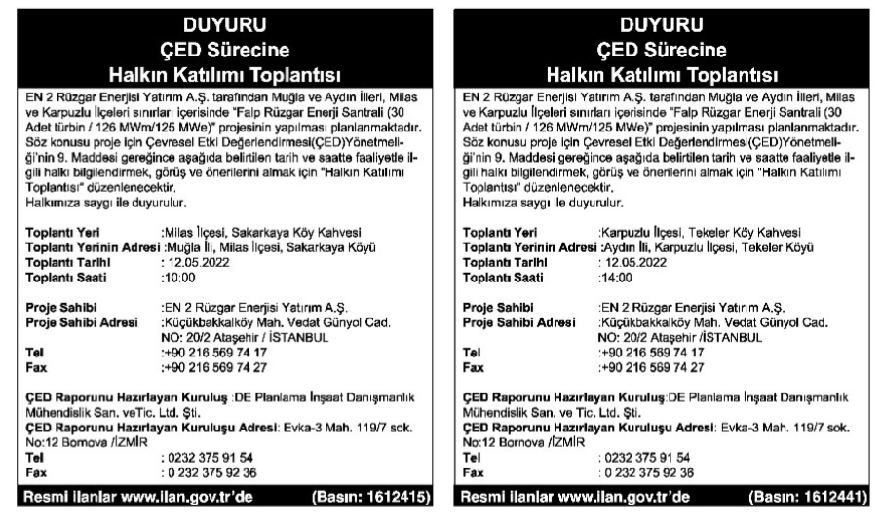
Figure 5-1 Project Advertisement in National Newspaper
Source: Local EIA, 2024

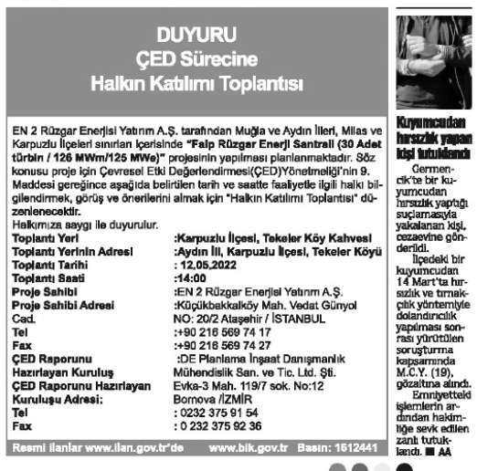
Figure 5-2 Project Advertisement in Local Newspaper
Source: Local EIA, 2024
The Project team sought to inform locals of the Project’s expected activities during construction and operation of the Project via visual presentations on the environmental impacts and suggested mitigation efforts. During the meeting, participants raised several concerns and questions regarding the project. Key issues included potential negative impacts on pine nut trees and beekeeping livelihoods, as well as the need to protect rock paintings and other cultural heritage sites through surface surveys prior to construction. Participants also inquired about biodiversity protection measures, tree cutting practices, the planned road route, and climate change studies. Additional concerns were expressed about archaeological sites, Sarıçay water resources, and the overall regional benefits of the project. The potential effects on endemic species, wildlife, the Carian Road, habitats, and trekking routes were also highlighted. Furthermore, attendees discussed the impacts of 6-meter-wide road construction on forests and beekeeping, the implications for ecotourism potential, and the visual impacts from turbine and road construction. While participants expressed general support for wind energy, some opposed the current site selection.

  - Engagement During ESIA Process
During the development of the ESIA for the FALP WPP Project, two separate social field studies were conducted to ensure a comprehensive understanding of the Project’s potential environmental and social impacts. The first field survey was conducted between July 11–17, 2024, by a six-member field team. The social impact analysis was carried out by surveys and interviews conducted with PAPs and Mukhtars during field studies, observations, evaluation and analysis of secondary data, and evaluation of review of the reports relevant to the AoI. A supplementary field study was carried out between March 20–23, 2025, to account for the finalization of the Energy Transmission Line (ETL) and access road alignments and to assess additional potential Project impacts. As part of the ESIA field studies, household surveys were carried out in six settlements within the Milas district of Muğla province, namely Sakarkaya, Kayabükü, Çukur, Konak, Narhisar, and İkiztaş. In total, 79 surveys were completed across these locations, with 25 in Sakarkaya, 6 in Kayabükü, 14 in Çukur, 9 in Konak, 10 in Narhisar, and 15 in İkiztaş. In addition, mukhtar (village head) interviews were conducted in all six settlements to gather local insights and support stakeholder engagement. Key concerns raised by the communities involve restricted access to grazing areas, limited water availability, road degradation, and potential losses in beekeeping activities.
As the Project does not involve any physical displacement or resettlement of households, a full Resettlement Action Plan (RAP) is not required. Instead, a Livelihood Restoration Plan (LRP) has been prepared to specifically address economic displacement impacts, including potential losses of land-based livelihoods, access restrictions and associated vulnerabilities.A Livelihood Restoration Plan (LRP) is prepared in May 2025 by ERM in line with the IFC Good Practice Handbook: Land Acquisition and Involuntary Resettlement (2023). The primary goal will be to help those affected restore their income-earning capacity and achieve sustainable livelihoods post-project implementation.
As per the requirements of ESR5 and ESR10; LRP provides methods for compensation and engagement for affected persons, relative to the scale and severity of their losses or impacts.
The LRP provides further measures for the compensation and livelihood restoration. A Community Liaison Officer (CLO) was also appointed in advance to ensure regular communication and coordination with local stakeholders. According to the information provided by Enerjisa, continuous engagement activities with Project-Affected Persons (PAPs), local administrations and mukhtars have been carried out since before the site mobilization. Records of these engagement activities, including consultation forms and meeting notes shared by Enerjisa.

Future Engagement
Stakeholders will be consulted regarding the following matters (at a minimum):
- Disclosure of the SEP, NTS, BMP;
- Execution of a census/inventory of PAPs (see Section 4);
- Implementation of the Livelihood Restoration Plan;
- Consultations on issues pertaining to grievances, as needed;
- Monthly check-ins with stakeholders once construction and assembly begin to manage expectations, concerns, gather feedback, and share relevant updates on Project development.
The CLO shall namely be responsible for managing, overseeing, and ensuring that engagement pertaining to the Project is carried out effectively, in an appropriate timeframe and as per the other protocols mentioned in this SEP and IFC PS 1 and ESR10. In addition, the Client has appointed corporate level GBVH Focal Point and a Labour and Working Conditions Expert in order to manage and follow-up the implementation of the relevant sub-topics.
The following engagement efforts will be carried out to mitigate and manage impacts related to land acquisition and livelihoods:
- Socio-economic baseline;
- Census/Inventory of PAPs;
- Disclosure and implementation of the LRF;
- And Consultations on issues pertaining to grievances related to PS5.
The Client expanded their organizational capacity for SEP implementation by hiring a Community Liaison Officer (CLO) to facilitate and manage community engagement.
Moreover, it is imperative that engagements with PAPs be in good faith and is meaningful; takes place throughout the planning, implementation, monitoring and evaluation of the land acquisition and resettlement process (including livelihood improvement or restoration); engages all relevant affected groups (men, women, children, elderly, and vulnerable groups/persons); and is well documented. All stakeholders shall be aware and informed of their entitlements, rights, opportunities and benefits and the client shall facilitate engagement efforts that are simple, practical, accurate and provide culturally appropriate documentation. Module three of the IFC’s Good Practice Handbook on Land Acquisition and Involuntary Resettlement will serve as a basis for developing relevant and appropriate engagement activities with relevant stakeholders.

Participation Activities
The Client may use the following types of engagement throughout the Project, depending on their relevance:
- Public participation events;
- Multilateral or bilateral meetings;
- Workshops and seminars;
- Focus group discussions;
- Round table meetings and/or Q&A Sessions;
- Interviews with stakeholders;
- Electronic polling/surveys;
- Social media posts;
- And implementing/maintaining a functioning internal/external grievance mechanism.

Stakeholder Engagement Action Plan
Table 5-1 below provides a high-level overview of expected engagement activities with their corresponding objectives, format of engagement and which key stakeholders the engagement is directed at. The action plan specifies the timing and frequency of key engagement efforts throughout the remainder of the Project’s lifetime.
This overview will serve as a guideline for key engagement activities but shall be adjusted accordingly as the Project develops. The action plan is a key element for the Project developer’s periodic review, along with other planning, documentation, and monitoring material laid out in this SEP.
Specific engagement activities will consider vulnerable groups in the planning process to ensure physical accessibility for different PAPs. Gender sensitivity will be taken into consideration as needed, with the Project taking increasing efforts to fortify gender-specific dialogue and spaces for discussions. Child support/care, translation services, legal aid etc. are some examples for how generic engagement activities will be sure to consider all PAPs.
When implementing and planning each specific activity, the principles of proportionality and inclusivity will always be considered. Proportionality will guide the depth and frequency of engagement, with more intensive efforts directed toward those most impacted by the project’s risks and benefits – thus, the engagement action plan below includes specific measures for vulnerable persons and PAPs that will be affected by land acquisition and displacement impacts. The project developer will ensure inclusivity by maintaining open and accessible communication channels, offering tailored engagement formats such as gender-specific focus groups, multilingual materials, and mobile outreach for transient populations. Proportionality will be upheld by prioritizing more frequent and in-depth engagement with stakeholders who face higher levels of impact, such as those experiencing land loss, livelihood disruption, or environmental risks.

Table 5-1 Stakeholder Engagement Action Plan
Engagement Activity | Objective/ Expected Feedback | Format of Engagement | Target Stakeholder(s) | Timing/Frequency | Responsibility & Support
Project Disclosure
Project Disclosure (dissemination of Project related documentation to the public) | Fulfil international lenders’ consultation requirements by publicly disclosing (via website) the NTS, SEP, LRP and BMP. | The E&S documents (SEP, BMP and NTS) will be disclosed in English and Turkish through a dedicated section on the Project website, ensuring accessibility for governmental and municipal authorities.  The CLOs will communicate and share the relevant documents in person at the mukhtar level to ensure accessibility and transparency. | Key stakeholders and Affected Communities in the Social AoI  All interested (internal and external) stakeholders | During the E&S documents Disclosure period | Enerjisa Enerji Üretim A.Ş.
Engage with stakeholders on the E&S documents through in person meetings (interviews/focus groups/open house event or public meeting) | Facilitate understanding about the Project and E&S documents conclusions, as well as proposed mitigation measures  Solicit feedback on the Project and E&S documents  Contribute to open and positive relationship with Project stakeholders  Use stakeholder and local input to ensure that identified social impacts are properly evaluated and assessed. | Disclosure and feedback through in person meetings with stakeholders met during previous engagement rounds  Physical open house event or public meeting held near Project Area (TBD)  Information about open house/public meeting provided to communities via announcements to stakeholders and through posts in the Mukhtar office.  Timing for these events will be specifically defined so as to maximize participation. | Stakeholders met in the previous engagement rounds, including vulnerable groups and Affected Communities in the Social AoI  Key local community leaders  Environmental and Social NGOs  All interested stakeholders, including from the Social AoI, as well as national/international stakeholders and interested parties | During the E&S documents Disclosure period | Enerjisa Enerji Üretim A.Ş.
Summarize stakeholder feedback from disclosure process and integrate stakeholder feedback into the SEP (as needed) | Report on disclosure feedback and integrate it into the Final SIA as appropriate | Preparation and distribution of a summary report on disclosure and how submissions have been considered and addressed | All interested stakeholders | During the E&S documents Disclosure period | Enerjisa Enerji Üretim A.Ş.
Post-Project Disclosure
Engagement related to Cultural Heritage | Collaborate with local branches of the Ministry of Culture and Tourism to ensure effective management of chance finds and support cultural heritage preservation initiatives throughout the project lifecycle. | Planned cooperation with the Ministry of Culture and Tourism’s local branches on chance finds management and cultural heritage initiatives. Co-develop a formal protocol with Ministry input, including reporting steps, temporary work stoppage procedures, and documentation requirements.  Host training sessions for construction teams, CLOs, and community members on how to recognize and report chance finds.  Create public information boards or exhibitions in collaboration with the Ministry to showcase any findings or heritage-related initiatives. | Ministry of Culture and Tourism, CLOs, Project workforce, | Quarterly during pre-construction;Bi-annually during construction. | Enerjisa Enerji Üretim A.Ş.
Engagement related to biodiversity risks/impacts | Address stakeholder concerns related to biodiversity impacts—especially tree cutting and bird collisions—and to collaborate with expert institutions to enhance biodiversity protection throughout the wind farm lifecycle.  Understand local concerns, identify culturally or ecologically significant trees, and co-develop mitigation strategies. | Town hall meetings, focus groups, and participatory mapping. Visual maps, translated materials, and grievance channels.  Invite biodiversity experts to co-host roundtables and workshops. Review project biodiversity risks, validate mitigation plans, and explore nature-positive design options. Develop Joint recommendations and monitoring protocols. | Local communities near forested or ecologically sensitive areas. ; Environmental NGOs; Universities with ecology or environmental science departments (e.g., Middle East Technical University, Istanbul University).  Forestry Directorate and Ministry of Environment, Urbanization and Climate Change.  Bird conservation groups and ornithologists.  Local farmers and landowners affected by habitat changes. | Twice during pre-construction; and biannually during construction | Enerjisa Enerji Üretim A.Ş.
Engagement related to livelihoods | Help identify alternative income-generating skills for those suffering with economic displacement.  Co-design livelihood restoration activities with PAPS for LRP adjustments.  Ensure transparent communication about compensation mechanisms and land tenure changes. | Co-design additional livelihood restoration strategies that reflect community needs and preferences via gender-disaggregated focus groups and scenario planning sessions.  Legal literacy sessions, one-on-one advisory meetings, and visual guides.  Quarterly community feedback meetings and participatory monitoring committees. | Displaced land users, women, youth, and informal workers.  Unemployed youth, displaced farmers, women seeking formal employment. | Quarterly during pre-construction; and biannually during construction | Enerjisa Enerji Üretim A.Ş.
Engagement related to fire risk | Educate local residents and workers on fire risks, prevention strategies, and emergency response.  Coordinate fire prevention and response planning with official agencies.  Identify high-risk zones and community assets vulnerable to fire.  Reduce fire hazards during project activities (e.g., welding, machinery use).  Promote vigilance and reporting during dry months. | Interactive workshops with visual materials and live demonstrations.  Joint planning meetings, site inspections, and protocol alignment.  Community-led mapping sessions using satellite imagery and local knowledge.  Toolbox talks, fire drills, and distribution of fire safety kits.  Posters, radio announcements, and mobile alerts. | Local villagers, farmers, seasonal workers, school groups, and site personnel.  Forestry officials, municipal fire departments, and environmental officers.  Residents living near forest edges, informal land users, and landowners.  Contractors, subcontractors, and technical staff. | Quarterly during pre-construction; and biannually during construction | Enerjisa Enerji Üretim A.Ş.
Engagement related to community investment | Identify priority infrastructure needs (e.g., roads, water access, school repairs) through participatory planning.  Support youth development and build local capacity for future employment.  Strengthen local economic resilience through small business support. | Community meetings and needs assessments.  Engagement with schools and families to co-design scholarship criteria and vocational training pathways.  Engagement with cooperatives and entrepreneurs to co-design grant or mentoring programs. | Village residents, local leaders, school administrators, farmers.  Students, teachers, unemployed youth, parents.  Small business owners, farmers, artisans, women-led enterprises. | Quarterly during pre-construction; and biannually during construction | Enerjisa Enerji Üretim A.Ş.
Engagement related to community health and safety | Educate local residents on potential health and safety risks (e.g. noise, shadow flicker, emergency procedures).  Disseminate clear, accessible information about safety measures and health monitoring (if relevant). | Community Health and Safety Workshops and Information Sharing via in-person workshops with visual aids and local language interpreters.  Verbal feedback during Q&A; post-event surveys.  Hotline and WhatsApp feedback; suggestion boxes.  Flyers, posters, social media posts, radio announcements. | Local residents, community leaders, school representatives.  General public, especially vulnerable groups (elderly, children, non-native speakers). | 1-2 times during ESIA phase, and 1-2 times directly prior to Project construction | Enerjisa Enerji Üretim A.Ş.
Engagement related to emergency preparedness and response | Align emergency response protocols with local health services and authorities. | Roundtable meetings with municipal health officials and emergency services.  Structured feedback forms; collaborative planning inputs. | Local health clinics, fire departments, municipal safety officers. | Bimonthly during planning and construction. | Enerjisa Enerji Üretim A.Ş.
Engagement related to construction related Impacts | Inform local communities about the construction timeline, potential disruptions (noise, dust, traffic), and mitigation measures.  Provide a direct line for reporting concerns or incidents during construction.  Keep stakeholders informed about upcoming activities and any changes to plans.  Build trust and transparency by showing safety measures and environmental controls in place.  Ensure respectful behavior of workers toward local communities and minimize social friction. | Pre-Construction Community Briefing sessions via townhalls, with visual presentations  Open Q&A, comment cards, follow-up surveys.  Construction Impact Hotline and WhatsApp Channel, capturing real-time complaints, suggestions, and incident reports. Dedicated phone line and WhatsApp number managed by community liaison officers.  SMS alerts, Facebook posts, local municipality website updates.  Passive feedback via engagement metrics; active feedback via comments or replies.  Stakeholder Site Walks; i.e. Guided site visits with safety briefings and PPE provided.  Construction Worker Code of Conduct Awareness Campaign using Posters, leaflets, briefings at local gathering points. | Local residents, community leaders, municipal representatives, transport users, nearby businesses. Community representatives, local NGOs, journalists.  Local residents, especially women and vulnerable groups. | Once prior to construction and monthly/bimonthly during the construction phase | Enerjisa Enerji Üretim A.Ş.
Meetings with key stakeholders around employment/training, especially for construction crews and drilling operations | Support local participation in Project employment as much as possible and ensure that working conditions are safe, healthy and decent | Targeted meetings/focus groups | Project employees | Monthly during the construction and annual during the operation. | Enerjisa Enerji Üretim A.Ş.
Ongoing engagement with Affected Communities and key stakeholders | Facilitate collaboration with stakeholders  Collect feedback and inputs on positive and negative impacts of the Project as indicated in this SEP | Targeted meetings; individual meetings, focus groups | Local communities in the Social AoI  Key local authorities and other stakeholders | Continuous during the construction and operation | Enerjisa Enerji Üretim A.Ş.
Regular meetings with workers | Check in regarding grievances and grievance mechanism  Obtain input and feedback on implementation of risk prevention and mitigation measures with relevance to worker health and safety and labor and working conditions | Targeted meetings, focus groups | Workers (internal stakeholders) | When required, but at a minimum quarterly. | Enerjisa Enerji Üretim A.Ş.
Implementation of the LRP and on-going engagement with stakeholders on matters related to IFC PS5 | Implement the LRP as per document and IFC PS 5 guidelines  Initiate and carry out engagements related to compensation and resettlement (TBD)  Development of a GLAC by Q1 2026 for disclosure to stakeholders.  Collect and integrate feedback  Provide active updates to relevant parties and PAPs  Address Concerns of Landowners with Limited Legal Literacy | Targeted meetings, focus groups, bilateral negotiations, Hosting legal aid sessions and distributing brochures explaining rights in plain language.  Develop multilingual outreach materials and use visual formats for low-literacy audiences. | Local communities in the Social AoI  PAPs  landowners/users  Landowners affected by land acquisition with limited legal literacy. | On-going | Enerjisa Enerji Üretim A.Ş.
Ongoing disclosure of Project information, including grievance management reporting | Provide updates about the Project and key construction and operation milestones  Provide regular feedback on grievance management, incl. resolved grievances. | Project grievance mechanism to update  Develop multilingual outreach materials and use visual formats for low-literacy audiences. | All interested stakeholders | Quarterly, during the construction and operation period | Enerjisa Enerji Üretim A.Ş.
Considerations for vulnerable groups
Tailored Engagement for Elderly and Illiterate Populations | Ensure inclusive participation of elderly, illiterate, and socially isolated individuals. | Face-to-Face Village Consultations via organizing informal meetings in village coffee houses and homes using visual materials and simplified language. | Elderly residents, illiterate individuals, and those with limited mobility.  Landowners affected by land acquisition with limited legal literacy. | Quarterly during LRP implementation and construction. Annually during operation period. | Enerjisa Enerji Üretim A.Ş.
Engagement with Seasonal Agricultural Workers | Identify and engage seasonal workers who are often overlooked due to their transient status.  Improve Access to Livelihood Restoration Programs.  Empower women seasonal workers and reduce risks of exploitation. | Mobile outreach teams visiting fields during working hours.  Provide translated materials for non-Turkish-speaking workers (e.g., Kurdish or Arabic speakers).  Ensure grievance mechanisms were accessible via SMS or WhatsApp  Partner with UNDP and Turkish Red Crescent for certification and job placement.  Collaborate with local mukhtars, cooperatives, and NGOs. | Seasonal agricultural workers, informal land users, land owners, vulnerable persons affected by LRP, Migrant farm workers, including Syrian refugees, Kurdish and Arab minorities, and internally displaced persons (IDPs) | Quarterly during LRP implementation and construction. Annually during operation period. | Enerjisa Enerji Üretim A.Ş.
Female-only focus groups | Increase participation of women, who are often excluded from public meetings.  Ensure that women’s economic roles and needs are reflected in LRP design and implementation.  Ensures women can influence livelihood restoration activities, such as training programs or resource allocation.  Engage female facilitators to lead discussions.  Discuss unpaid care work, access to compensation, and safe working conditions.  Include GBVH awareness and reporting pathways.  Increases visibility and accountability, helping to identify and address risks of harassment or exclusion early. | Women-only focus groups facilitated by female staff; scheduling meetings outside domestic work hours. | Women in rural communities, especially female heads of households. | Quarterly during LRP implementation and construction. Annually during operation period. | Enerjisa Enerji Üretim A.Ş.

  - Accessibility and Inclusitivy
Stakeholder engagement for the project will be designed to be inclusive, accessible, and culturally appropriate to ensure meaningful participation from all relevant groups.
Language and Formats
All public information materials and engagement activities will be conducted in Turkish, which is the primary language spoken in the Project AoI. Where relevant, materials may also be translated into English for the benefit of national or international stakeholders, regulatory agencies, and project partners. All documents to be disclosed to stakeholders will include clear and concise executive summaries to enhance accessibility and understanding. The Non-Technical Summary (NTS), being a standalone summary document, will be written in plain, easy-to-understand language and translated into Turkish to ensure it is accessible to all stakeholders, including those without technical backgrounds.
Engagement activities will be conducted in Turkish, using clear and plain language, and supported by translation or interpretation services where necessary to accommodate non-Turkish-speaking participants. The consultants or project personnel conducting engagement activities will use easy language so all stakeholder, including those without technical background or knowledge of the project will understand the key information that is relevant to them. At each engagement session it will be clearly communicated that questions are welcomed and can be raised at any point.
Timing and Venues
Cultural appropriateness will be ensured by scheduling meetings and workshops at times that respect local customs, religious observances, and community priorities. Local facilitators familiar with regional norms will be engaged to support dialogue in a respectful and contextually sensitive manner, if needed.
Meetings and consultations will be held at accessible community venues within reasonable proximity to stakeholders, ensuring compliance with physical accessibility standards for persons with disabilities. Digital engagement methods, such as online surveys, video conferences, and social media platforms, will also be utilized to reach stakeholders who may be unable to attend in person.
Supporting Tools
Visual and oral communication tools, such as posters, maps, and illustrated summaries, to support understanding among stakeholders with varying literacy levels, will be used, when conducting engagement sessions.
Gender Inclusivity
Gender inclusivity will be a central consideration in engagement planning, with targeted efforts to ensure women’s participation and voice in decision-making processes. This will include but is not limited to:
- Organizing women-only consultation sessions where appropriate
- Providing childcare support during meetings,
- Ensuring female representation in community liaison roles, and
- Having female officers as focal point for GBVH related issues.

Stakeholder Engagement for Change Management
The SEP is an open and “living document” meaning that the Client and its Project team must ensure that it is actively reviewed and updated to fit changing Project needs throughout the entire life cycle. Specific measures related to stakeholder engagement, the grievance mechanism(s) and grievances, stakeholder issues, organizational capacities etc. should be of particular focus during review, evaluation, and reporting. The SEP shall ensure that it reflects Project changes, especially any related to or influencing economic and social risks and impacts. These reviews shall take place at least annually.
As Project developments ensue, changes to the SEP may include (but are not limited to):
- Changes to Project scale, scope, size;
- Adjustments to organizational capacities, such as roles and responsibilities;
- Changes to approaches or materials, such as technology used for the Project or strategies;
- And the scale, nature, and severity of certain social risks and impacts may be different or develop differently than anticipated and their evaluations, management, and mitigation efforts may need to be adjusted accordingly.
Moreover, any changes to the Project development team, especially those working on implementing the SEP and facilitating engagement activities with stakeholders, will also be relayed to stakeholders in an appropriate timeframe. Any developments that the Client is unable to mitigate will be considered significant and will be subject to lender notice. Lenders will also be notified of any changes to Project scope, design, or activities that could potentially impact environmental and social impacts.

Grievance Mechanism
The Client has established a grievance mechanism and a Grievance / Request Management Procedure. This section presents the process for stakeholders to submit grievances or concerns and for the Client’s Project team to maintain and manage the grievance mechanism. The mechanism is crucial for managing Project-related grievances, especially any issues or concerns related to the Project’s environmental and social impacts.
Section 6.2 describes how the Community Grievance Mechanism (CGM) will function, this is mainly directed for stakeholders that are part of the local communities, are considered Project-Affected-Persons (PAPs), and are within the Project’s direct and indirect social Area of Influence (AoI); Section 6.1.2 expands upon the workforce grievance mechanism that will be used primarily during the construction phase by construction workers; Section 6.1.3 provides the approach for managing grievances from the Project’s contractor employees and sub-contractors employees. Other internal employees to the Client’s company or Project-team shall manage grievances internally.
A grievance refers to any concern or complaint that an individual or group raises relative to Project developments or activities; grievances may stem from real experienced impacts as well as perceived impacts of the Client’s actions and intentions. Suggestions, request for information (RFI), reporting of injuries or specific incidents, and stakeholder feedbacks are also considered grievances and will be processed as such.
The Client understands that unexpected impacts can occur throughout the duration of the entire Project and maintaining open, honest, and on-going communication with stakeholders, and an appropriate GM is key to properly managing them. Effective grievance management is also essential to building and maintaining trust and local buy-in over long-term timelines.

Purpose and Principles of a Grievance Mechanism
A GM is needed to ensure that stakeholders have adequate avenues to communicate their concerns, complaints, feedback and questions to the Project development team and appropriate protocols for the team to respond to grievances in a transparent, fair, and systematic manner.
A proper GM is intended to help ensure that the rights, needs, and liberties of stakeholders are acknowledged and respected, for feedback to be integrated into Project development, and for environmental and social risks and impacts to be managed over a Project’s long-term time horizons. Addressing grievances conveys the Project team’s respect for stakeholders and their thoughts, interests and experiences; it is ultimately a mitigatory practice that helps prevent issues from becoming exacerbated with further significant consequences. A successful GM will help ease overall engagement with stakeholders for all parties involved.
The following criteria are crucial to ensuring that the GM is successful and effective for the nature, scale and scope of this Project:
- A GM cannot replace judicial or administrative remedies, nor should it be treated as such;
- The Project team will ensure that addressing grievances will be done in a prompt, consistent, appropriate, respectful, human rights-aligned and timely manner; failure to address concerns in an appropriate time frame may be serious and potentially infringe upon stakeholder rights.
- The GM must be accessible, open, and receptive to all stakeholders regardless of their vulnerabilities, status, identity, age, literacy capabilities etc. This also requires that the grievance mechanism have multiple avenues for stakeholders to submit grievances and that they are culturally and economically appropriate formats, languages etc. It is crucial that stakeholders are aware of how and where to find/access the GM and that any changes are explicitly and actively communicated.
- GM shall be equitable, in the sense that it will provide users with access to necessary information and ensure that the process is independent. It will also serve the unique needs of and consider obstacles that vulnerable stakeholders might face; those responsible for handling and managing grievances shall be sensitive to the issues raised by and situations of vulnerable people (i.e. victims of gender based violence or harassment).
- The GM shall be publicized so that all stakeholders are actively aware of how to access the GM as needed. The status and developments of grievance resolution shall also be documented and shared with stakeholders.
- The GM shall also be predictable, in the sense that users are provided with an explanation on the handling of grievance process, milestones, timeline and types of solutions provided.
- A GM shall be both transparent and confidential; stakeholders shall be aware of how grievances are managed and receive reporting on key findings, trends, patterns, or changes, yet also have their privacy and anonymity respected and protected. This shall be handled with additional consideration when dealing with sensitive data or situations.
- Stakeholders shall be free of any manipulation, intimidation, coercion, or retaliation and bear no cost or retribution related to the GM and its usage.
- The GM must establish clear protocols for the Project team to respond to concerns indirectly, verbally, or in writing.
- Compensation and conflict resolution may also need to be provided in some circumstances. Both the process and its outcomes will be aligned with national and international human rights standards.
- Grievance resolution shall be well-documented.
- Finally, the GM will provide a source of continuous learning and improvement for the Project team and its overall environmental and social performance.
A fundamental part of the GM is the maintenance of a well-documented and up-to-date grievance register (see Appendix B). The Project team and person(s) directly responsible for grievance oversight and handling will abide by the protocols laid out in this SEP to ensure that actions are consistent and fair. Anonymity shall only be shared with individual consent and discretion.
Moreover, this GM is relevant or applies to all Project components and activities until decommissioning has been completed. It will be reviewed and updated regularly to properly ensure that the GM is relatively adjusted to the scale of any Project changes and developments.

Community Grievance Mechanism
The intended users of the CGM are primarily external stakeholders, including local and nearby communities, PAPs, and other public stakeholders. It is crucial that the community has avenues to submit their concerns and incidents and have them appropriately in place to avoid adverse or exacerbated impacts to local populations.
The Client will ensure that information on how to access the GM is available and visible to external stakeholders (e.g., through sings posted in surrounding project areas, in local newspaper, in vehicles and trucks, in the project’s website, etc.).
This is a key requirement under PS1, but also helps manage the social risks and impacts related to: community health, safety, and security (PS 4); land use, land acquisition and resettlement or displacement (PS 5; and cultural heritage assets (PS 8).

Workforce Grievance Mechanism
The Client is responsible for the implementation, management, and monitoring of all grievances, whether they are from internal or external stakeholders. Therefore, a well-functioning workforce grievance mechanism is crucial to manage potential risks and impacts related to the Project’s direct workforce, especially during the construction phase. A proper GM is an embedded mitigation measure that helps decrease and manage the risks and impacts related to labor and working conditions and OHS (IFC PS 2 and PS4). This protocol will help deal with incidents such as workplace injuries and harassments, addressing workplace conflicts, and responding to other concerns from the Project’s labor pool.
The impacts and issues between the locally Affected Community and Project employees are usually distinct and require slightly different approaches to processing and resolution. Thus, IFC PS2 requires a grievance mechanism for workers to raise and have their workplace concerns addressed. There will be a separate Grievance Register for The handling of the workforce and community grievances but handling of the grievances will proceed in the same manner; it is likely that workforce grievances may need to be treated as high-risk cases depending on the severity of the incident.
All the Project’s workforce shall be informed of the grievance mechanism and how to use/access it upon hiring, as well as during or regarding potential retrenchment processes. The Client will ensure that information on how to access the GM is available and visible to the workforce (e.g., through signs posted in working areas, in the intranet, etc.). This does not override or substitute worker’s right to freedom of association, participation in other collective agreements or their right to submit grievances via workers’ organizations and unions.

Third Party Grievance Management
IFC requires that all Project employees have access to an effective grievance mechanism, including third party (any external auditors, or individuals related to the Project) or subcontractor employees. If the hired third party or subcontractor cannot provide a well-functioning and effective grievance mechanism, then the Project’s workforce grievance mechanism will be made available to them. Otherwise, the Client shall provide an alternative grievance mechanism for the subcontractor workforce that adheres to the requirements under the IFC PS.
As subcontractors and their employees are also part of the Project workforce, they shall also be made aware of the grievance mechanism and how to utilize it when they are hired. Such employees can also exercise their rights and submit grievances elsewhere and shall engage in workers’ associations as they see fit.

Grievance Mechanism Process
Figure 6-1 below provides an overview of the process for filing and addressing issues the grievance mechanism.
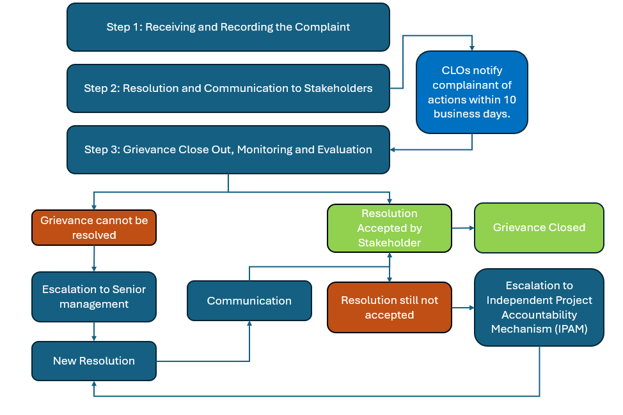
Figure 6-1 Grievance Mechanism Process
The protocol for handling Workforce and Community Grievances will generally be the same and is described in the remaining sub-sections of this chapter. A Community Liaison Officer (CLO) has been appointed to the Project and the CLO will be responsible for the implementation of the entire SEP, including management of the grievance mechanism. The CLO must ensure that the mechanism is well-functioning and effective, and be relatively easy to use so that Project proponents avoid the risk of tiring stakeholders with additional labor or increasing any adverse experiences with the Project.
The handling of all grievances will be thoroughly documented for reporting to stakeholders and overall monitoring and evaluation of the Project’s risks and impacts to stakeholders and general social/socio-economic environment.
Each step of the process is discussed in greater depth in the following sections. Roles and Responsibilities are described in Section 7.

Step 1: RECEIVING AND RECORDING THE COMPLAINT
Stakeholders shall be able to submit grievances at various avenues/sources; this ensures that all stakeholders can access the relevant Project GM easily. The appointed Project CLO who will manage overall stakeholder engagement and the GM. They will be responsible for ensuring that the requirements and protocols laid out in this SEP, other Project management plans, and IFC requirements are abided by when handling grievances and working with the GM.
Stakeholders can submit grievances:
- Verbally or in writing to the CLO/Project Team, at the following contact details: yekares2@enerjisauretim.com, +90 216 512 40 00
- In person or in writing via regular mail using the attached grievance form included in Appendix C.
- Electronically, by submitting a form on the Project website: https://yekares2.enerjisauretim.com
During employee onboarding and communication about the GM to stakeholders, the Client will make sure to inform which submission channels ensure anonymity and confidentiality.
Stakeholders will be informed as to how the GM shall be used and where to access it; they will have access to the most recent SEP, including a GM, at all times. Other supplementary communication materials may be required of the Client, to convey this information. The language shall be clear and concise and materials will be shared in English and Turkish.
All grievances and related requests are registered within 2 business days and managed through the eBA system of Enerjisa using the Grievance Registration and Closure Form (See Appendix C). The system ensures that all supporting documentation such as financial records, correspondence and donation protocol documents linked to grievance or request are properly attached and tracked throughout the process.
High-risk or sensitive grievances, such as those involving Gender-Based Violence and Harassment (GBVH), child protection issues, serious safety incidents, or alleged discrimination, will be treated as a priority. Such cases will be acknowledged immediately and assigned to a designated Case Manager within 48 hours to ensure a prompt, sensitive, and confidential response, including referral to appropriate support services where required.

After logging the grievance in the register, the CLO must acknowledge the receipt of the grievance in writing and this must be delivered to the complainant.
Once the grievance is initially logged, the eligibility will be determined. Grievances will only be considered “admissible” for subsequent processing and potential remediation if the claim is related to the Project activities (during any phase). This includes both direct and indirect activities from/by Project proponents and/or the Project’s contractors and subcontractors. Grievances are not admissible and will be considered ineligible if they meet any of the following criteria:
- The complaint is not related to the Project and has no obvious relationship with the activities of the Project in any of its phases, including activities carried out by the Project’s contractors, subcontractors or their employees.
- There are other more appropriate mechanisms or formal institutions or community procedures to deal with the complaint (which will be indicated to the complainant).
If a complaint is not admissible, the Client must relay that information in writing with a justification as to why it cannot be processed further. In cases where the grievance is not related to the Project, the complainant is guided to contact the appropriate party or authority.
If necessary to ensure that the grievance is processed, the CLO will request further information from the complainant to determine admissibility and/or deal with the grievance in the most fitting manner. Requests for further information must also be documented in writing.

Step 2: RESOLUTION AND COMMUNICATION TO STAKEHOLDERS
For valid grievances, the CLO will assign specific actions to the relevant Project Company personnel, depending on the nature of the grievance to assess and determine appropriate resolution measures.
The Project commits to ensuring that all valid grievances are addressed in a timely and transparent manner. Upon receipt, the Community Liaison Officers (CLOs) assign specific actions to the relevant Project Company personnel, depending on the nature of the grievance, to assess and determine appropriate resolution measures.
The CLOs will inform the complainant of the actions taken or planned within a maximum of ten (10) business days. In cases where the issue requires a more detailed or complex review, this will be communicated to the complainant along with an indicative timeframe for resolution.
Enerjisa Üretim aims to resolve each grievance within thirty (30) business days from the date of registration.

Step 3: Grievance Close Out, Monitoring and Evaluation
After the resolution is formally agreed upon and there are no outstanding protocols, the grievance can be closed out. A final agreement must be documented in writing to constitute the closure of grievance. The status of closure shall be adjusted accordingly in the Grievance Database and all documentation shall be safely kept. The CLO will send a Grievance Closure Letter once it is closed out.
Grievances will be categorized as:
- Closed by agreement: resolved with the complainant’s consent,
- Closed without agreement: resolved without mutual consent, or
- Closed and referred to court: when the complainant decides to take legal action.
Anonymous grievances will also be closed with documented evidence while keeping the complainant’s identity confidential.
If the Client fails to meet the agreed upon requirements/commitments, then the stakeholder can file another grievance or direct the issue to senior management. Feedback from the resolution of grievances shall be documented for monitoring and evaluation purposes. The Project team will also periodically conduct internal reviews and assessments on the efficacy of the SEP and GM and adjust accordingly. Further details on monitoring and evaluation are listed in section 8.
  - Escalation Process
A robust escalation mechanism provides a clear pathway for grievances that cannot be meaningfully resolved at the Project level to be elevated for further review. If a grievance cannot be resolved satisfactorily at the Project level, even after escalation through internal layers, it should be referred to the EBRD’s Independent Project Accountability Mechanism (IPAM) as an external recourse. IPAM is the independent accountability arm of the EBRD, established to allow communities, workers, and other stakeholders to raise concerns associated with EBRD-financed projects beyond the client’s internal processes. The referral to IPAM provides a neutral, third-party process for problem solving and compliance review, ensuring that unresolved issues can still be addressed transparently and with institutional oversight.

Gender-Based Violence and HArassment Provisions
The IFC’s Good Practice Note on Addressing Gender-Based Violence and Harassment highlights that risks of gender-based violence and harassment (GBVH) against members of the local community where a temporary workforce and influx of male workers are required for Project developments. During the construction phase for renewable projects there is often an influx of temporary and a predominately male workforce who are not already members of the local community into shared community spaces or areas with local community members. A traditionally male working environment, different social norms, power dynamics, new financial power, and separation from communities are among a host of different explanations for why there may be exacerbated harassment, exploitation, abuse towards women; land acquisition during construction also suggests increased GBVH risks. Similarly, nations that have relatively weak rule or law, higher levels of corruption, the risks of GBVH and protection for reconciling such impacts may become exacerbated.
This GM includes additional guidelines to mitigate potential GBVH related incidents and that if such impacts do arise they are handled with care, respect, and sensitivity:
- GM shall be easily accessible and safe to all stakeholders and local communities.
- Stakeholders shall all have the option to submit any grievances confidentially and their anonymity will be preserved and respected.
- Women-only focus group discussions (FGDs) will be organized to inform and empower women about the GM, how to access it, and their rights to report GBVH incidents confidentially and without fear of retaliation.
- The Client will ensure that a specific person (female or other preferred gender) is available for stakeholders to approach directly with sensitive and urgent issues such as GBVH related incidents.
- If GBVH related incidents are identified within Project related activities stakeholders shall be provided, if necessary, with protection and support measures, as well as compensation in particular situation. Protection and support measures may involve counselling, medical and healthcare support and treatment, access to other resources (women’s health organizations or additional healthcare services), leave from work, changing work location, among others.
Incidents involving GBVH will be deemed high risk and urgent and have a fast-tracked response approach to ensure that the situation is resolved before further harm can occur. GBVH related cases will be transferred immediately to the GBVH Focal Person, which will handle the case together with the GBVH Committee which constitutes of in-house experts that have received special training on GBVH related issues. Access to such data will be strictly limited to authorized personnel, and all procedures will follow a survivor-centered approach, ensuring that no case is disclosed without the consent of the survivor. Enerjisa also has in place a Procedure for the Prevention of Discrimination, Violence, and Harassment.

Support for Vulnerable Groups
In addition to gender-based measures, the GM also includes provisions for other vulnerable groups, such as the elderly or persons with disabilities, to ensure equitable access and support:
- The grievance mechanism will be adapted to the needs of elderly stakeholders, including in-person support through CLOs, phone reporting, and assistance with completing grievance forms if required.
- Community outreach activities will be scheduled at convenient times and accessible locations for elderly participants, minimizing travel or physical strain.
- Information about the GM will be provided in plain language, with visual aids or oral explanations as needed, to ensure comprehension by those with limited literacy or cognitive challenges.
- Elderly stakeholders raising grievances will receive timely responses and appropriate support, including coordination with local social services if needed.
- CLOs and project staff will receive training on the specific needs of vulnerable groups, including cultural norms, accessibility challenges, and sensitivity when engaging with the elderly, people with disabilities or other identified groups, to foster trust and ensure respectful treatment.
These measures ensure that the grievance mechanism is inclusive, culturally appropriate, and responsive to the needs of all vulnerable groups, maintaining confidentiality, transparency, and timely resolution of concerns while promoting equitable participation in the project’s engagement processes.

Monitoring and Reporting
Grievances and their resolutions will be identified, logged, and tracked in the Project’s grievance register; an example is provided in Appendix B. The handling of grievances and affiliated processes shall also be periodically reviewed to ensure compliance with the protocols stipulated in this SEP; this is crucial to maintain transparency, consistency, and fairness when resolving all stakeholder issues. Moreover, it is crucial that during review there is crucial confirmation that timeframes have been properly respected to ensure that full stakeholder rights are respected and prevent issues from worsening.
Section 8 addresses documentation, monitoring, and reporting requirements in more depth.

Roles and Responsibilites
Table 7-1 defines the scope of roles and responsibilities regarding SEP implementation and management of the GM.
Table 7-1 Roles and Responsibilities for SEP Management
Role | Responsibility
Falp WPP Project Manager / Construction Manager | - Overall accountability for Project implementation including grievance work stream  - Management of relations with authorities and other key stakeholders  - Responsible for providing the resources (budget, training etc.) necessary for implementing this SEP
Social Affairs Team Leader / Community Liaison Officer (CLO) / Labour and Working Conditions (LWC) Expert | - Coordination of local engagement team and other activities involving community relations  - Ensuring messaging is consistent and clear when engaging stakeholders  - Communicate the CGM process and obligations to Project personnel, contractors, and others engaged on the Project  - Regularly review the Grievance Register and SEP to ensure it is maintained and up-to-date  - Notify management of any high priority grievances  - Prepare reports that summarize stakeholder engagement activities including grievances received and resolution status
Social Affairs Team Leader / Community Liaison Officer (CLO) / LWC Expert / GBVH Focal Point | - Engage regularly with community stakeholders, including local community members, civil society organizations, landholders and land/resource users, households and vulnerable groups, with the aim of building the trust and respect of the community  - Ensure that affected communities are informed about the Project, its activities and its impacts, ensuring that stakeholders’ comments / questions and their concerns are considered and addressed  - Ensure effective operation of grievance management process including receipt, registration, investigation, resolution and monitoring of grievances  - Communicate grievance management process to communities and the outcome(s) of the grievance investigation(s)  - Manage and build the communications team  - Oversee external and internal communication  - Work closely with the Project Manager to prepare/validate communication materials aligned with Company standards and ensure messaging, branding, reputation management and, occasionally, government relations  - Ensuring messaging is consistent and clear when engaging stakeholders  - Communicate the CGM process and obligations to Project personnel, contractors, and others engaged on the Project  - Regularly review the Grievance Register and ensure it is maintained and up-to-date  - Notify management of any high priority grievances  - Prepare reports that summarize stakeholder engagement activities including grievances received and resolution status  - Receive GBVH grievances and address them through resolution  - Decide which GBVH grievances require investigation and coordinate the investigation  - Provide guidance for matters pertaining to livelihood restoration and displacement, compensation for and consultations with PAPs

Documentation, Monitoring, and Reporting
This section provides further specification on the overall approach and requirements related to documentation, monitoring, and reporting related to the SEP and its engagement activities and grievance management.

Documentation Tracking
All stakeholder engagement activities shall be systematically and comprehensively documented to ensure that actions on behalf of the Project development team are transparent and appropriate. This documentation will be used to track, evaluate and report on the Client’s social performance related to the Project and consistently weave in learnings and feedback into Project planning and development.
The following list includes the minimum of documentation efforts that the Project team will maintain:
- Stakeholder Register: a categorized list of stakeholders, including necessary or appropriate key contact details, will be maintained and adjusted/updated throughout the entire Project life cycle.
- Stakeholder Engagement Log: will be used to document, evaluate, and report on stakeholder engagement activities that have taken place. It shall include the date, location, a brief overview of the key parties that were present during the engagement/activity, what was discussed, and note any other relevant information, outcomes or responses from the meeting/mode of outreach.

- Meeting minutes (and template): the minutes from all meetings must be recorded and stored, including date and parties present; meetings that require sensitivity, privacy or that must preserve the anonymity of participants will be handled accordingly. A template for meeting minutes will also be created and shared with stakeholders among other materials so that they understand how engagements will be documented and stored.
- Event and meeting evidence: in addition to the meeting minutes, other evidence such as photographs and attendance lists shall also be gathered and kept. Participants shall be made aware of these efforts.
- Grievance Database: the grievance database will include submitted grievances in the grievance register (include internally and externally submitted grievances related to the Project) and how grievances have been addressed.
- Other Media: media monitoring of related press-releases or news stories that are related to or relevant for the Project shall also be gathered and kept; relevant resources shall be shared with the public.
The Project team will keep a specific folder or central location in which all of the SEP related files, documents and materials are kept. The documentation and storage of such materials will align with Turkish data protection laws and requirements.

Monitoring and Evaluation
The Client will create a monitoring management plan with clear processes for reviewing documentation and evaluating SEP implementation and engagement efforts. The general protocol will include (but is not limited to):
- Implementing planned SEP activities and specification on the key performance indicators that will be used to measure or evaluate performance and success;
- Monitoring and evaluation of communication and engagement activities (and other related materials such as engagement evidence and meeting minutes) between the Client and Project stakeholders during construction and operation period;
- Specification on the measures that will be used to assess media coverage that may be relevant to the Project, the Client and shareholders;
- Periodic evaluation of engagement strategies and engagement actions laid out in this SEP, such as updates to stakeholder mapping and analysis.
The Client shall encourage participatory engagement and feedback from stakeholders as often as possible, as such input can greatly optimize monitoring and evaluation efforts.
Furthermore, the client will also maintain a grievance log to track submissions to the GM. The log must note the issue, involved stakeholder or stakeholder group, classification of risk level, how it was ultimately dealt with, and if the grievance is considered on-going (still being resolved) or closed out. The Client will also consider monitoring:
- If the GM is appropriate and accessible for different stakeholders and how it can be improved;
- The total number of issues raised, and specification on the number of reports from vulnerable groups;
- De facto timeframes in which grievances were closed out, to gain an understanding of average response times and if stipulated timelines are feasible.
Table 8-1 below highlights the key performance indicators (KPIs) that will be used to track and evaluate if objectives have been sufficiently met or where improvement is needed.
Table 8-1 SEP Key Performance Indicators
Review topics | Objective | Indicators
Periodic review of publicly available Project documents such as Project information materials, flyers, the website, media materials and social media communications and other documents and or channels | - Assess whether publicly available Project documents and online platforms are up-to-date  - Assess cultural appropriateness of publicly available information  - Assess communications distribution channels to ensure they are available to communities in the AoI  - Assess level of engagement with stakeholders through formal and informal means (e.g., meetings with government agencies, public meetings and online engagement)  - Track issues raised by stakeholders  - Confirm the company is responding to issues in a timely manner  - Verify consultation activities include awareness raising about the GM | - Date of publicly available Project information; frequency of distribution  - Level of understanding of information by stakeholders  - Number and types of comments/feedback received by stakeholders  - Number and timing of responses to comments received  - Qualitative assessment of awareness of community stakeholders of GM through stakeholder engagement process
Monthly review of community grievances | - Assess whether grievances are correctly classified  - Identify trends in grievances  - Confirm that grievances are being adequately addressed | - Number of grievances by risk type  - Number and percentage (%) of grievances closed according to risk type and number of close out forms signed by the complainants  - Timeframes for resolution (and closure) by grievance type  - Number of repeated grievances from the same stakeholder  - Trends in numbers of complaints  - Topics of complaints
Monitoring of worker’s grievance mechanism effectiveness | - Evaluate and improve the overall effectiveness, fairness, and credibility of the worker grievance mechanism.  - Ensure that grievances are being handled promptly, transparently, and equitably, while also identifying patterns or systemic issues that require corrective action.  - Assess whether the mechanism is accessible, trusted, and responsive to worker concerns, and whether resolutions are leading to genuine improvements in workplace conditions. | - Percentage of workers aware of the grievance mechanism  - Percentage of grievances submitted anonymously  - Average time to acknowledge a grievance  - Average time to resolve a grievance  - Percentage of grievances resolved  - Percentage of complainants satisfied with the resolution  - Percentage of grievances appealed or reopened  - Number of corrective actions implemented as a result of grievances  - Trend of recurring grievances by type  - Number of reported retaliation cases
Quarterly review of GM | - Assess compliance with the grievance management process  - Evaluate progress in achieving GM objectives  - Identify improvements and update GM | - Level of compliance with the process  - Completeness of grievance register  - Number of grievances by level and type  - Timeframes for resolution (and closure) by grievance type  - Number and % of grievances closed according to type  - Number of satisfied responses from complainants by grievance type  - Number of repeats of a grievance from the same community stakeholder  - Qualitative assessment of awareness of community stakeholders of GM through stakeholder engagement process  - Qualitative assessment of trust in grievance management process through stakeholder engagement.
Effectiveness of engagement with vulnerable groups | - Ensure that engagement processes are inclusive, accessible, and meaningful for vulnerable groups,  - Allowing the perspectives of such groups to be heard and incorporated into project planning and decision-making. | - Number and percentage of identified vulnerable group members participating in consultations or engagement activities.  - Diversity of vulnerable groups represented (e.g., women, elderly, persons with disabilities, minority groups) in engagement sessions.  - Stakeholder feedback on the clarity, accessibility, and relevance of engagement materials and methods.  - Evidence of inputs from vulnerable groups being considered or incorporated into project decisions.  - Number of culturally and linguistically appropriate materials developed and distributed (e.g. translated brochures in easy language, illustrated poster etc.)  - Frequency and type of targeted outreach activities conducted for vulnerable groups (e.g. home visits to elderly, women-only FDGs etc.)  - Stakeholder satisfaction scores or qualitative feedback from vulnerable participants regarding engagement processes.

The M&E measures above apply to both, the Project construction and operation period.

Evaluation
The objectives specified in this SEP will guide evaluations of efficacy. Other evaluation methods will include but not be limited to:
- Gathering information from locals (e.g. perception and/or satisfaction surveys);
- Additional interviews or feedback sessions with stakeholders;
- Third party or external evaluations.
As the Project develops corrective actions will be carried out to improve performance and address any stakeholder engagement related matter that has not been successful. The SEP will be reviewed and updated at least quarterly to prevent deviations from the plan and address inefficiencies as early as possible.

Reporting to Stakeholders
The following two sub-sections specify how reporting on stakeholder engagement to internal and external stakeholders shall proceed.

Internal Reporting
Internal reporting documents will include, but may not be limited to:
- Monthly reports: will provide an overview of the engagement activities that have been carried out in that respective month. It will indicate the number of grievances submitted, addressed, and closed out. The individual responsible for the Project’s SEP implementation will be responsible for creating and delivering the monthly reports to concerned parties, namely the Project team and company’s E&S Management team(s).

- Grievance Mechanism reporting: will include an overview of main grievances reported (any identifiable patterns), summary of progress and efficacy of grievance mechanism approach and protocols, and participation.
- Progress on the set objectives for stakeholder engagement throughout reporting activities and their implementation:
  - Engagement activities carried out to date, which will indicate the stakeholders who were engaged, key topics addressed, expectations and concerns, etc.;
  - Project risks;
  - Any limitations, such as resourcing or organizational capacity, internal alignment etc.;
  - Priorities for next quarter;
  - Corrective actions undertaken or to be expected.
These reports will be circulated internally to the Project team, respective company management and relevant stakeholders, as required. Reporting and information circulation will respect all relevant data and privacy protection laws and requirements, especially regarding information and reporting pertaining to the grievance mechanism.

External Reporting
External reporting on stakeholder engagement can take different forms:
- After consultation sessions with stakeholders (e.g. community members, local leaders, PAPs), the Project team will communicate to what extent inputs have been integrated into Project activities and protocols and provide a brief summary on how grievances are being managed, for instance sharing key performance indicators outlined in Table 8-1 above to support building trust and increasing legitimacy of the GM among external stakeholders.
- A brief summary of stakeholder engagement efforts and GM key performance indicators will also be included in the Client’s annual sustainability reporting (if existent).
- If any other external stakeholders request information on stakeholder engagement and grievance management, the Client will prepare informative reports accordingly.

Appendix A Stakeholder CONSULTATION FORM AND CONSULTATION REGISTER

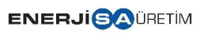 | ENERJİSA ÜRETİM
İSTİŞARE KAYIT FORMU
(CONSULTATION FORM)
Formu Dolduran Kişi  Person Filling Out the Form |  |  | Tarih  Date
Toplantı Gündemi  Meeting Agenda |  |  | Görüşme Kayıt No  Consultation Register Number
1- Toplantı Bilgileri
Meeting Information
Yetkili Kişinin Adı  Name of Authorized Person |  |  |  | İletişim Şekli  Type of Communication
İstişare Edilen Kurum  Institution Consulted |  |  |  | ​​☐​ Yüz Yüze  Face-to-Face
Telefon/E-posta  Phone/Email |  |  |  | ​​☐​ Telefon  Phone
Köy-Mahalle/İlçe/İl  Village/District/Province |  |  |  | ​​☐​ Diğer  Other
Paydaş Tipi
Type of Stakeholder
​​☐​ Kamu Kurumu  Public Institution | ​​☐​ PEK  PAP | ​​☐​ STK  Association/NGO | ​​☐​ İlgili Grup  Related Group | ​​☐​ Oda/Meslek Birlikleri  Chamber/Professional Body
​​☐​ Yüklenici/Alt Yüklenici  Contractor/Subcontractor | ​​☐​ İşçi Sendikası  Labour Union | ​​☐​ Medya  Media | ​​☐​ Üniversite  University | ​​☐​ Diğer  Other
2- İstişare Detayları
Details of the Consultation
Konu
Subject

Geri Bildirim
Feedback

Not
Note

Appendix B Sample Grievance Register

Appendix C Grievance Form

A - General Information
Project/Power Plant Name:
Name of the Recorder:
Form Registry No:
Date of Register:
Place of Register: |  | - Field/Area | - Office
Registration Type: |  | - Grievance | - Request
 |  | - Inside | - Outside
G/R Importance Level |  | - Low | - Medium □ High □ Critical
B- Means of Receiving Grievance
□ Telephone  □ Petition (Please attach one copy to this form) |  | □ Face-to-face meetings (site visits)  □ Community meetings (Public Information Meetings etc.)  □ e-mail □ Other: ........................
C.1- Information about the Applicant |  |  | C.2- Stakeholder Category
□ I would like to submit an anonymous request/ grievance |  |  | □ Local governmental authorities  □ Local residents  □ Local residents (community) [.... number of beneficiaries]  □ Private sector  □ Non-governmental organization  □ Contractor  □ Subcontractor  □ Enerjisa Project Employees  □ Workers of contractors/subcontractors  □ Consultant  □ Media
Name-Surname

Gender
Contact Information | Phone number:  e-mail adress:
Address
Location(neighborhood/village)
Location(district/province)
Signature of the Grievance /Request Holder Only Grievance/requests received through meetings, communication desk and visits will be signed.
D.1- Information about Grievance /Request |  |  | D.2- Grievance /Request Category
Detailed description of the Grievance/Request (Direct statements of the Grievance /Requestor can also be included): |  |  | □ Damage to land/crop/structure  □ Damage to access roads  □ Environmental impacts (pollution, dust, noise) □ Livelihood Impact (agriculture, livestock, etc.)  □ Use of lands without owner's consent and legal permission  □ Restricting access to natural resources/lands  □ Payment of usage fee or compensation  □ Expropriation  □ Resettlement  □ Demand for job or work from local  □ Working conditions  □ Laying off  □ Non-payments of workers' wages  □ Debt to local suppliers or subcontractors  □ Demanding any supports on education  □ Demanding any supports for households /individuals  □ Demanding any supports for neighbourhood /community  □ Demanding any supports for local authorities  □ Public health, safety and security grievance  □ Other: Please specify: ………………
E- Action Suggestions to be Taken Regarding the Grievance/Request

GRIEVANCE/REQUEST CLOSURE FORM

Name of the Recorder:
Date of Register: |  |  | ...../....../......
GRIEVANCE/REQUEST CLOSURE
In this section of the Closing Form, information on how the grievance was resolved or how the request was met will be included; if there is an expenditure made, its information will be entered; an explanation that the grievance/request is agreed with the grievance/request owner will be written and signed by grievance or request owner and the relevant Enerjisa employee and closed.
(For grievances received over the Internet, an e-mail response will be expected instead of a signature)
Actions Taken for Grievance/Request |  | Relevant Departments /Contractors/ Subcontractors
1-
2-
3-
4-
Amount of Expenditure:
Grievance/Requestor  Name-Surname and Signature | On behalf of Enerjisa  Title-Name-Surname and Signature

ERM has over 160 offices across the following countries and territories worldwide
Argentina  Australia  Belgium  Brazil  Canada  China  Colombia  France  Germany  Ghana  Guyana  Hong Kong  India  Indonesia  Ireland  Italy  Japan  Kazakhstan  Kenya  Malaysia  Mexico  Mozambique | The Netherlands  New Zealand  Peru  Poland  Portugal  Puerto Rico  Romania  Senegal  Singapore  South Africa  South Korea  Spain  Switzerland  Taiwan  Tanzania  Thailand  UAE  UK  US  Vietnam |  | ERM GmbH Brüsseler Str. 1-3  60327 Frankfurt am Main  www.erm.com

State appropriation of movable assets is addressed in the scope of other Turkish laws.
Source: IFC (2007), Stakeholder Engagement: A Good Practice Handbook for Companies Doing Business in Emerging Markets, International Finance Corporation, https://www.ifc.org/content/dam/ifc/doc/mgrt/ifc-stakeholderengagement1.pdf, last retrieved 29 April 2024.
Source: IFC (2023), Good Practice Handbook: Land Acquisition and Involuntary Resettlement, International Finance Corporation, https://www.ifc.org/content/dam/ifc/doc/2023/ifc-handbook-for-land-acquisition-and-involuntary-resettlement.pdf, last retrieved 29 Apil 2024.
https://yekares2.enerjisauretim.com/yeka-res-2-mugla-projeleri/gaia-res
Cultural appropriateness of grievance submission and handling can be understood for the project as a key principle to ensure that all stakeholders can raise concerns in a manner that is accessible, respectful, and aligned with local norms. Stakeholders will have the option to submit grievances either online or directly through CLOs. This dual approach is in some extend suitable in Türkiye, especially for stakeholders such as governmental bodies; municipalities that have reliable access to the internet and are accustomed to digital communication, making online submissions a convenient and efficient option. For those who may have limited digital literacy or lack internet access (e.g. farmers, elderly) grievances can be raised in person or via phone with CLOs or mukhtars who are trusted community representatives, ensuring inclusivity and maintaining trust. Cultural appropriateness is further reinforced through gender-sensitive approaches. To ensure culturally appropriate and inclusive stakeholder engagement, female Community Liaison Officers (CLOs) or designated female Focal Points will be assigned to receive grievances and feedback from women stakeholders, particularly regarding sensitive or gender-specific issues. This measure aims to facilitate equitable participation and effective communication, acknowledging that female stakeholders may prefer to interact with female representatives. The approach also supports confidentiality, enhances trust and aligns with local social dynamics where direct and relationship-based communication is valued.
IPAM is accessible here: Independent Project Accountability Mechanism
Source: IFC (2020), Addressing Gender-Based Violence and Harassment: Emerging Good Practice for the Private Sector, International Finance Corporation, https://www.ifc.org/en/insights-reports/2020/publications-gpn-addressinggbvh, last retrieved 29 April 2024.
Ibid.

